|  |  |
| --- | --- |
| Names | IDs |
| Mayar Ashraf | 192785 |
| Ahmed Sherif | 200483 |
| Salma Mahmoud | 202235 |

**22CSSE04H**

**Software Quality Assurance**

**Group 13**

Table of Contents

Screenshots: 2

Selenium IDE: 2

Mayar192785: 2

Ahmed200483: 6

Salma202235: 10

Selenium WebDriver: 13

TestNG: 13

Mayar192785: 13

Ahmed200483: 14

Salma202235: 14

Apache JMeter: 14

View Results as Table: 14

View Results as Tree: 15

Summary Report: 16

Graph Results: 16

Summary for each tool: 17

Issues and Difficulties: 17

# Screenshots:

## Selenium IDE:

### Mayar192785:

**Choose hotel category:**

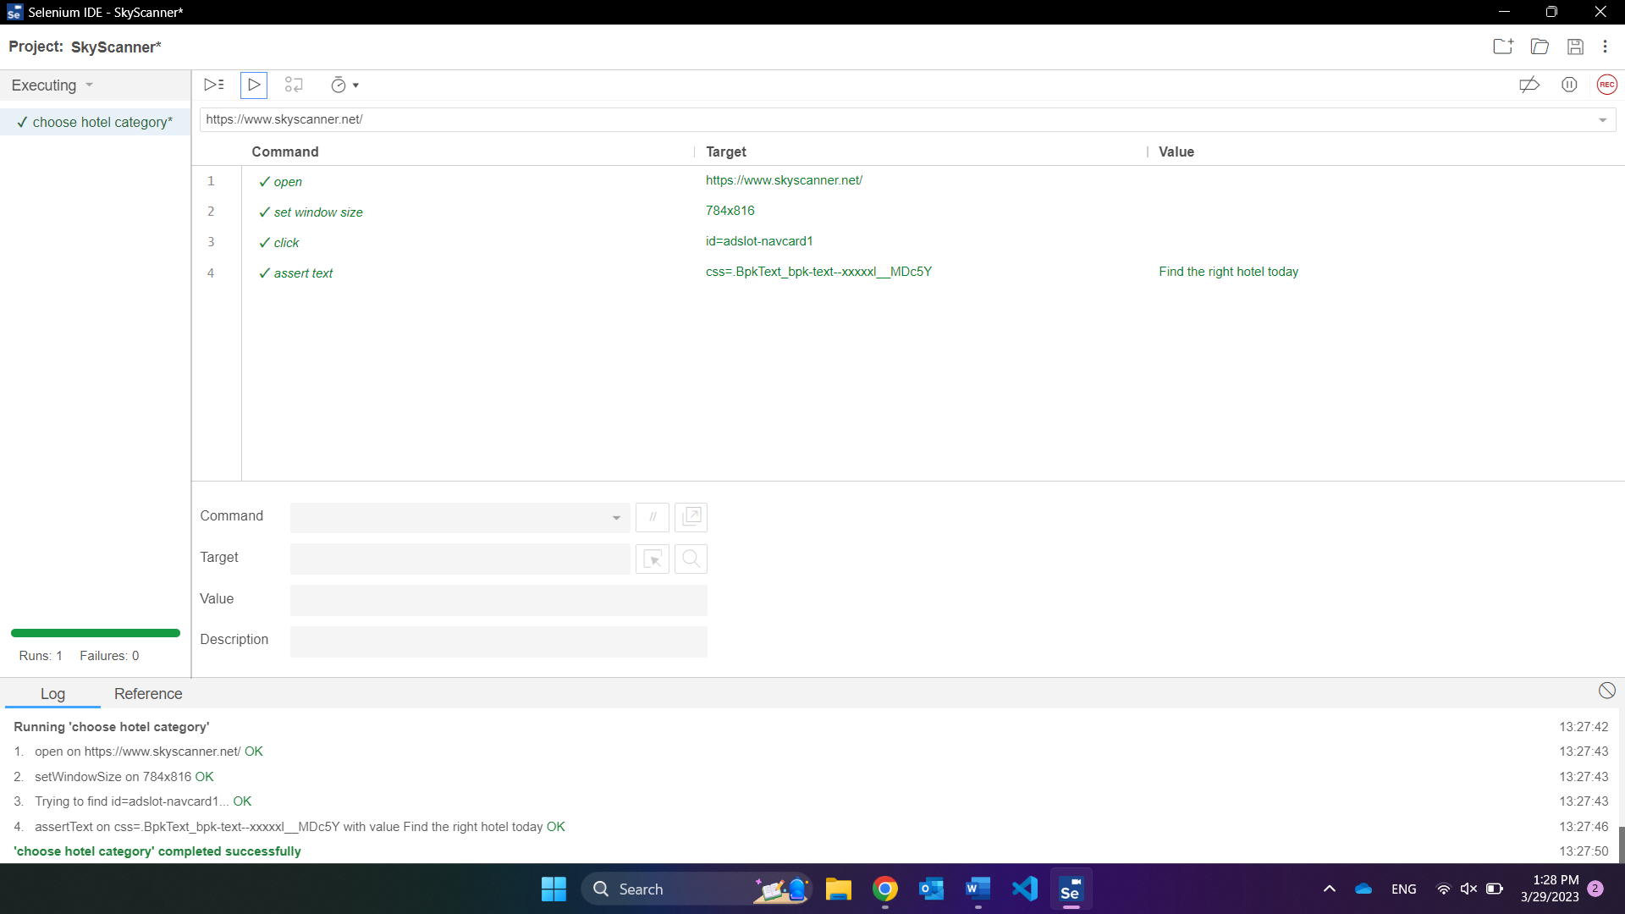

**Search for hotel:**

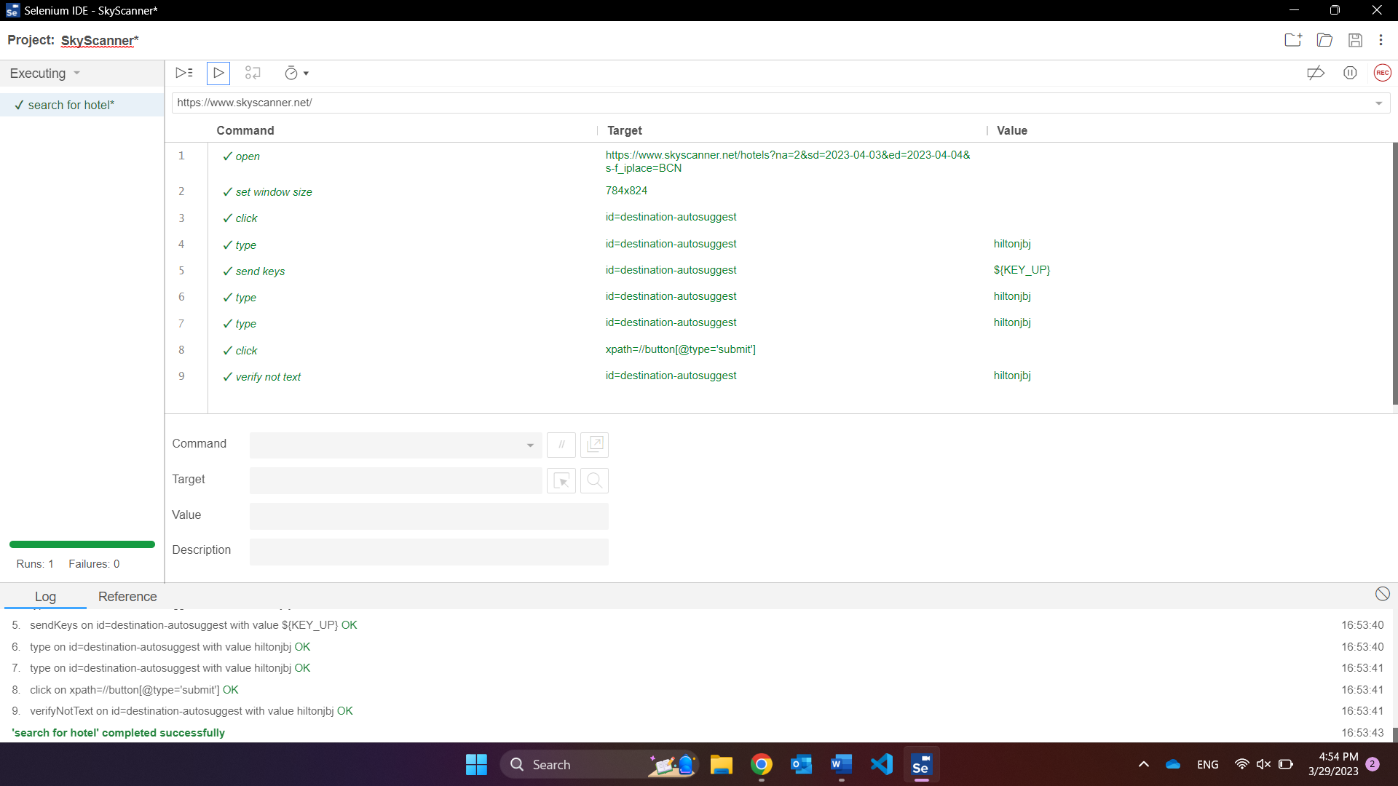

**View site:**

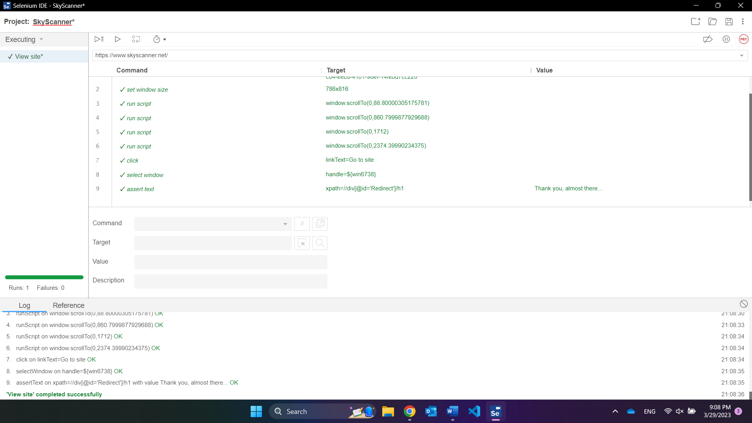

**Filter by budget:**

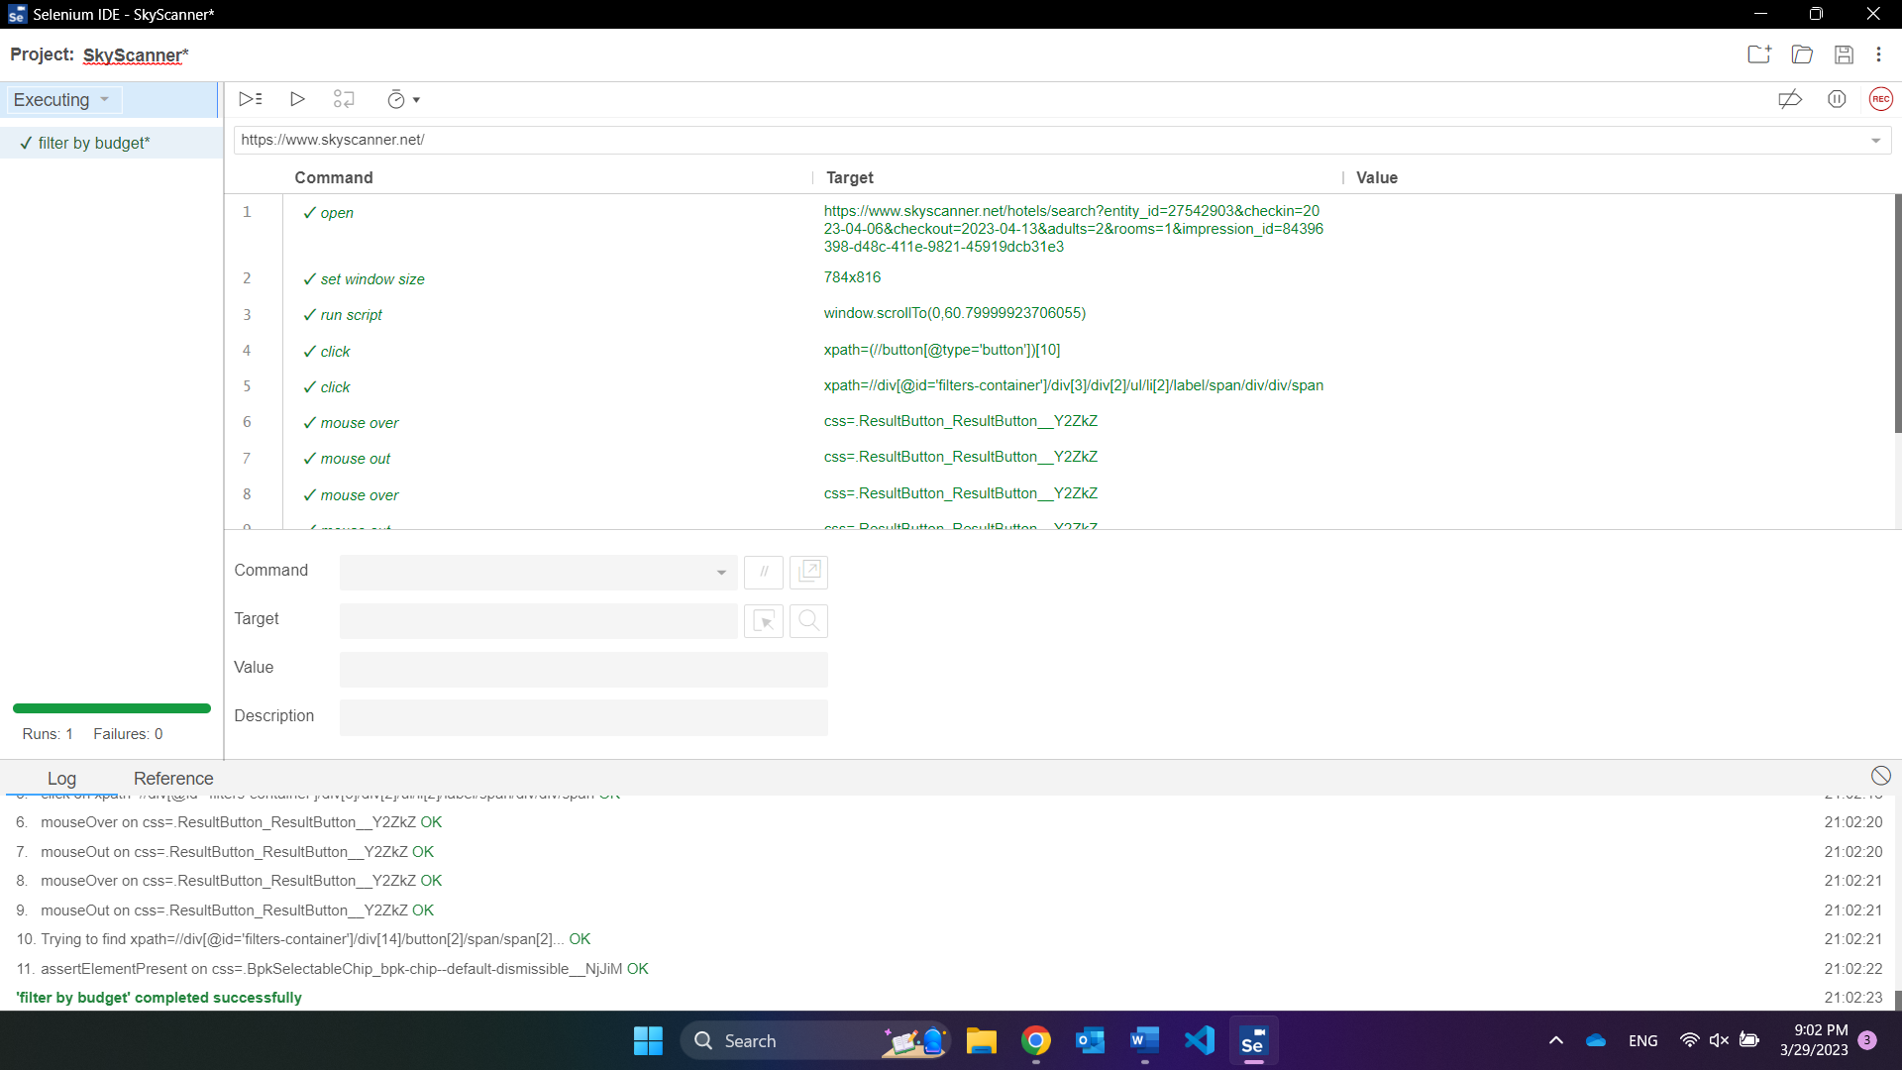

**View details:**

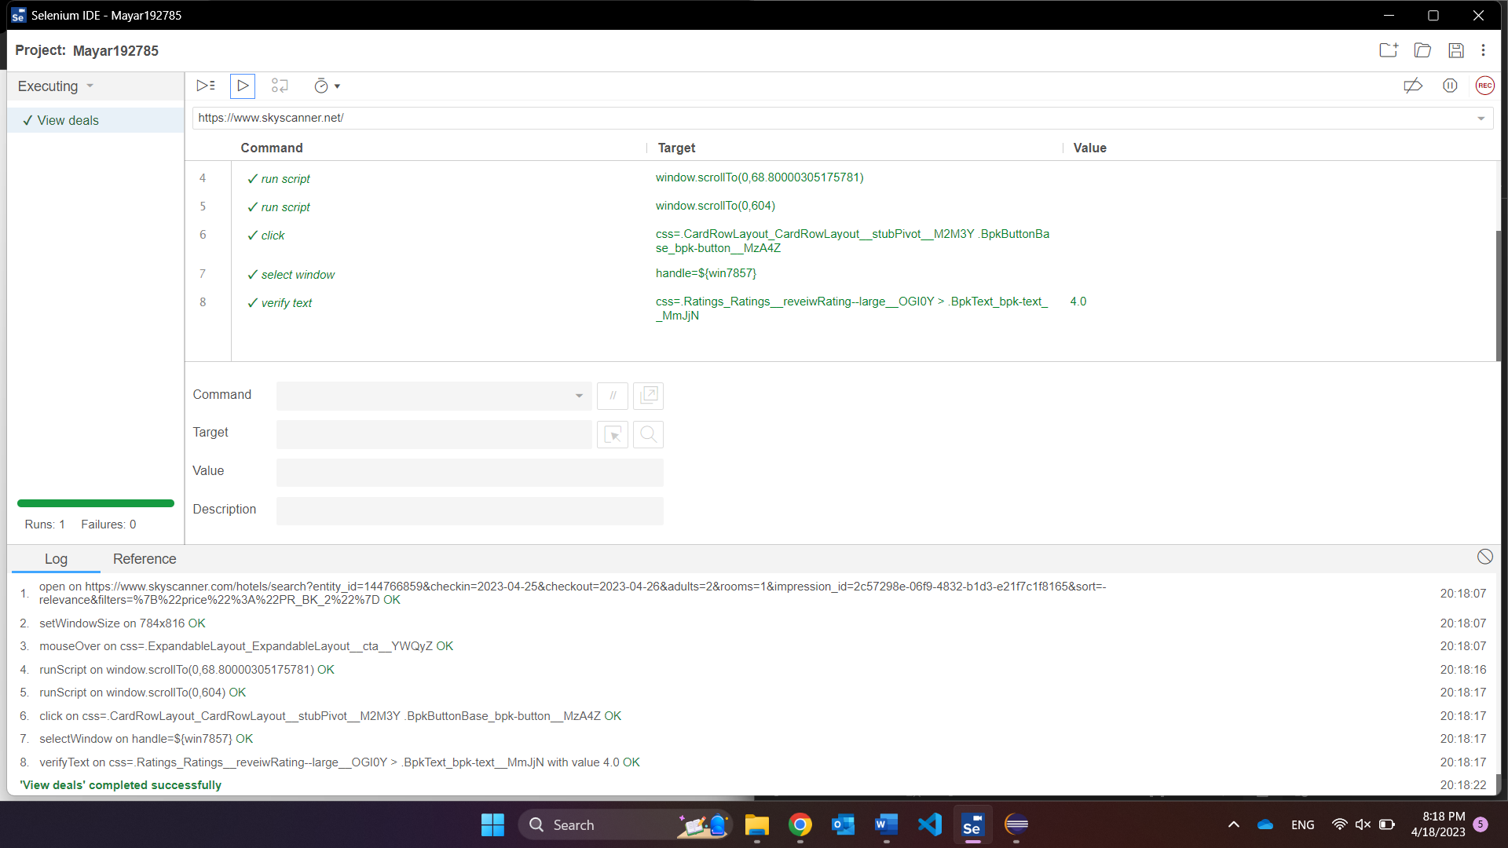

**Test suite:**

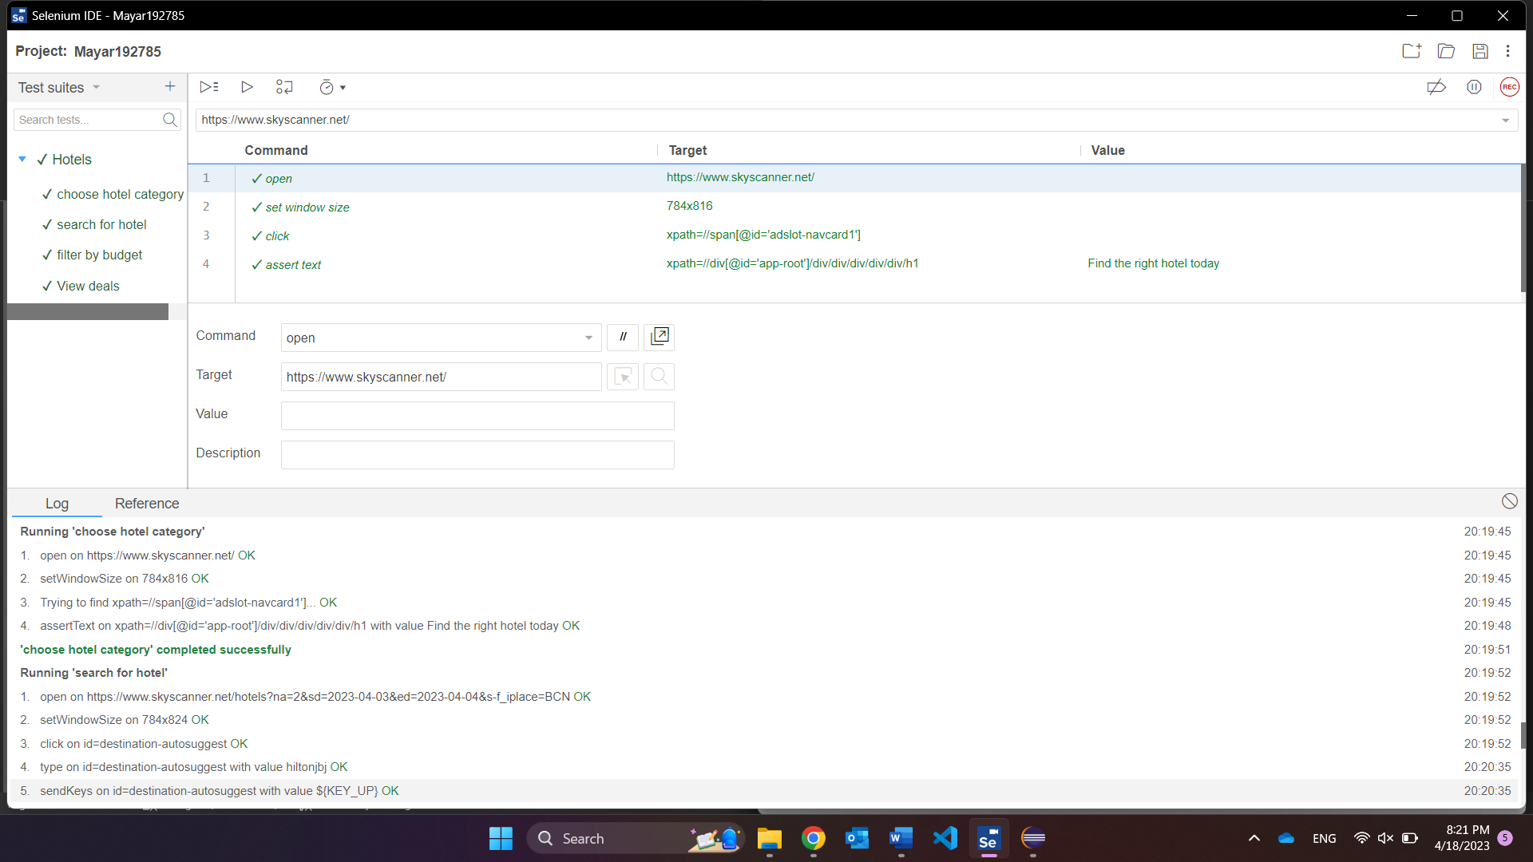

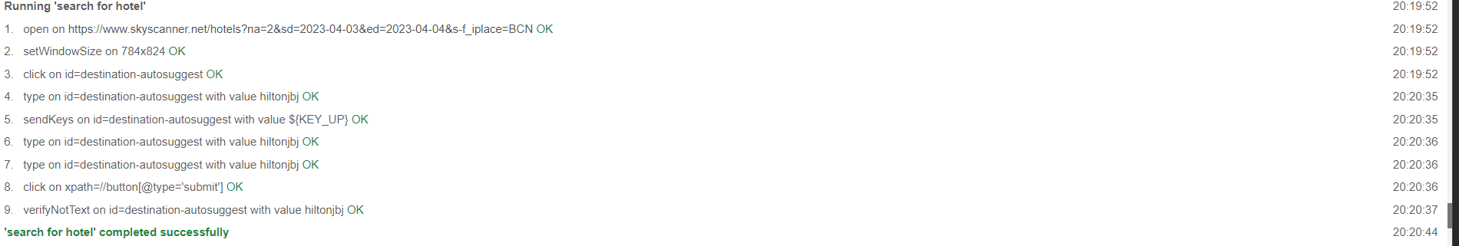

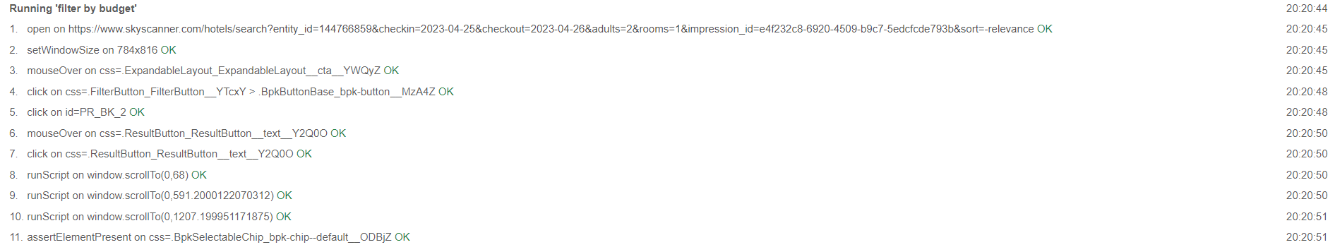

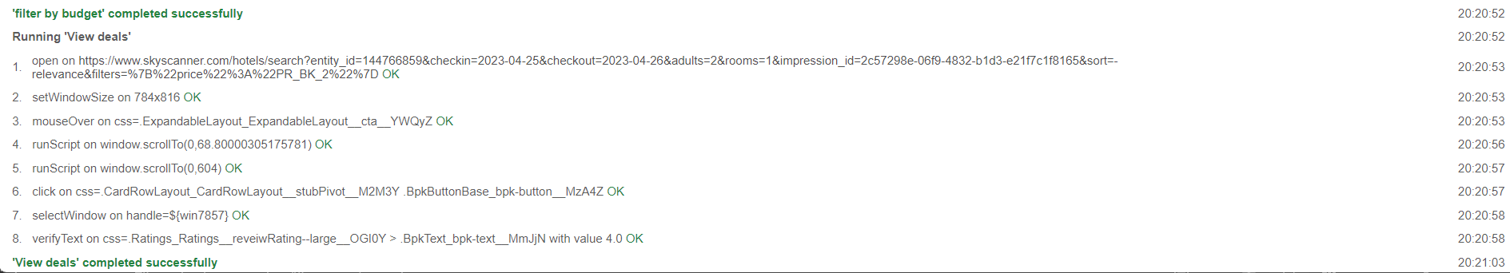

### Ahmed200483:

**Choose explore everywhere:**

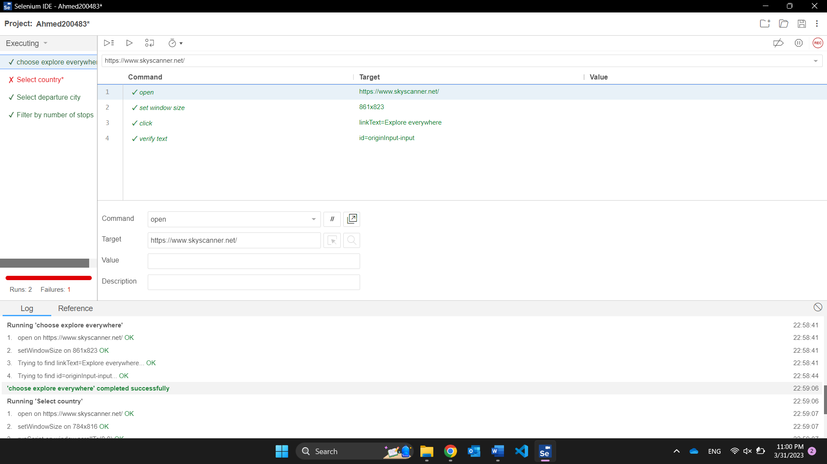

**Select destination country:**

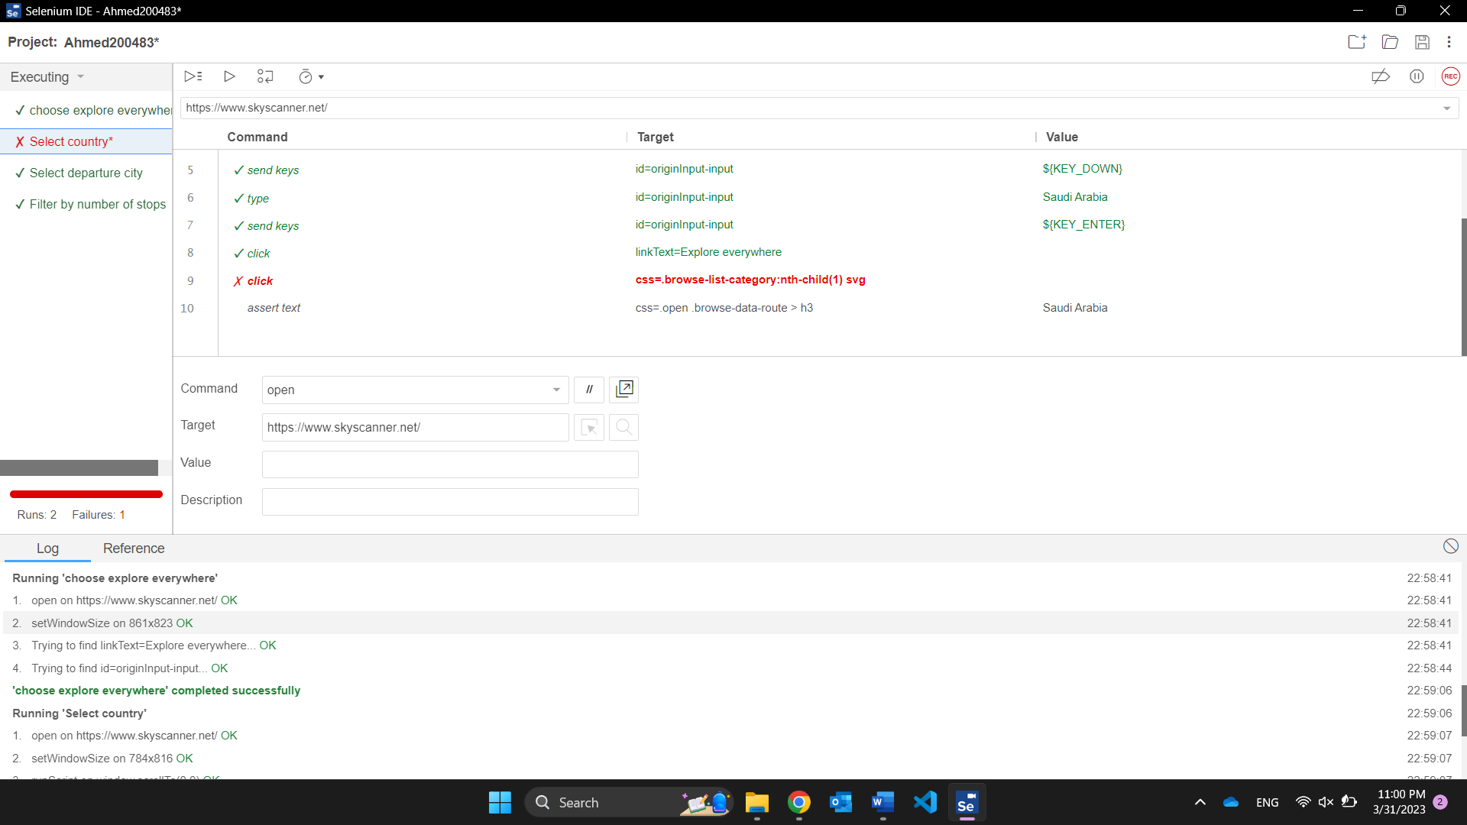

**Select flight deals:**

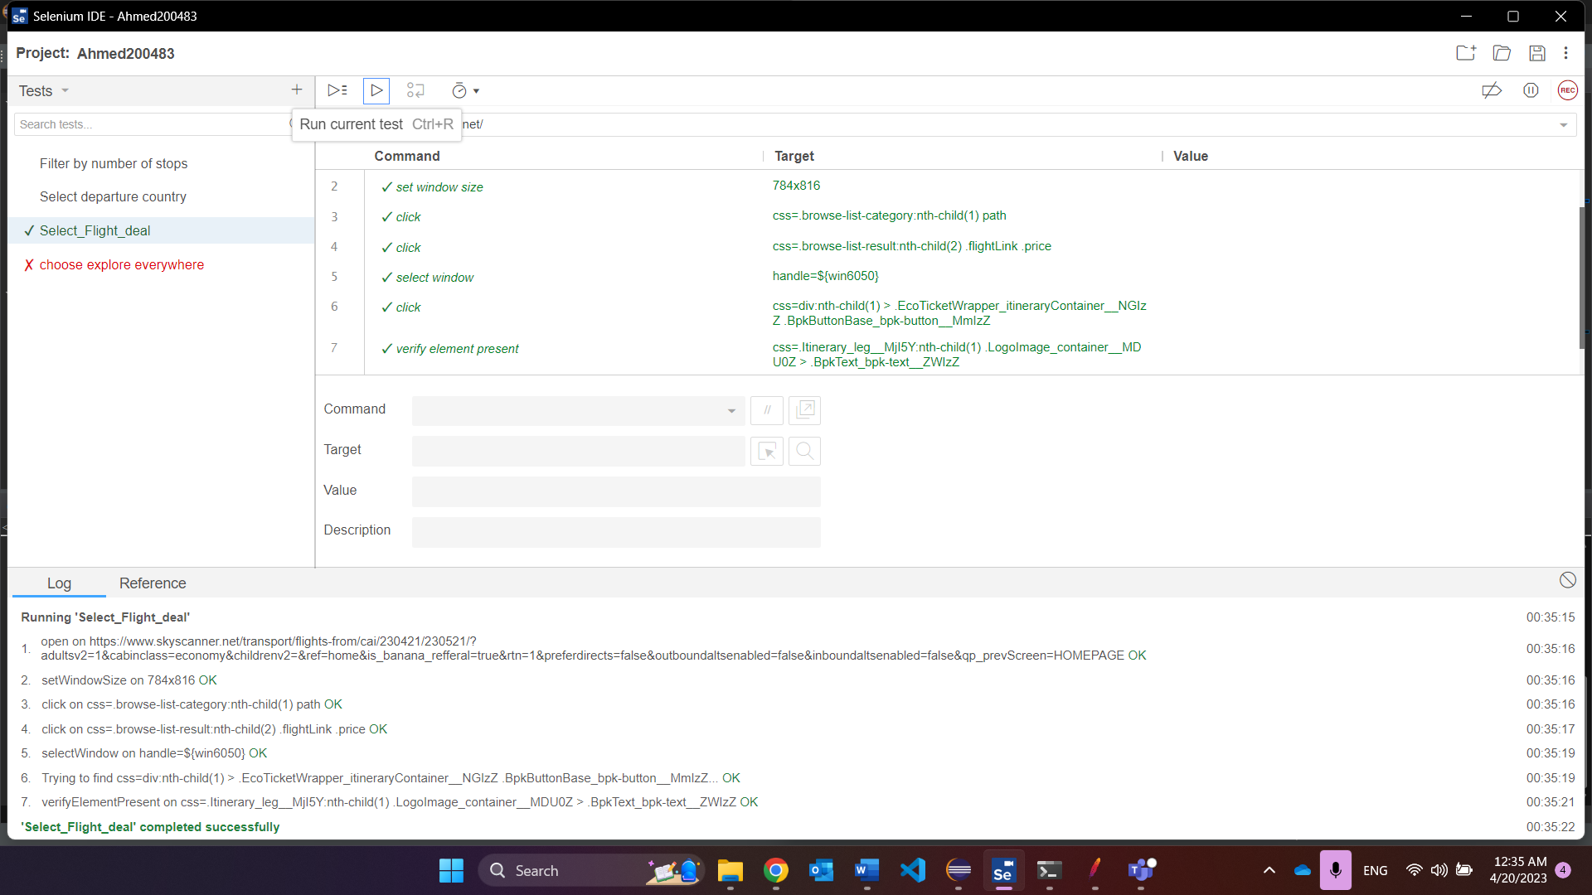

**Filter by number of stops:**

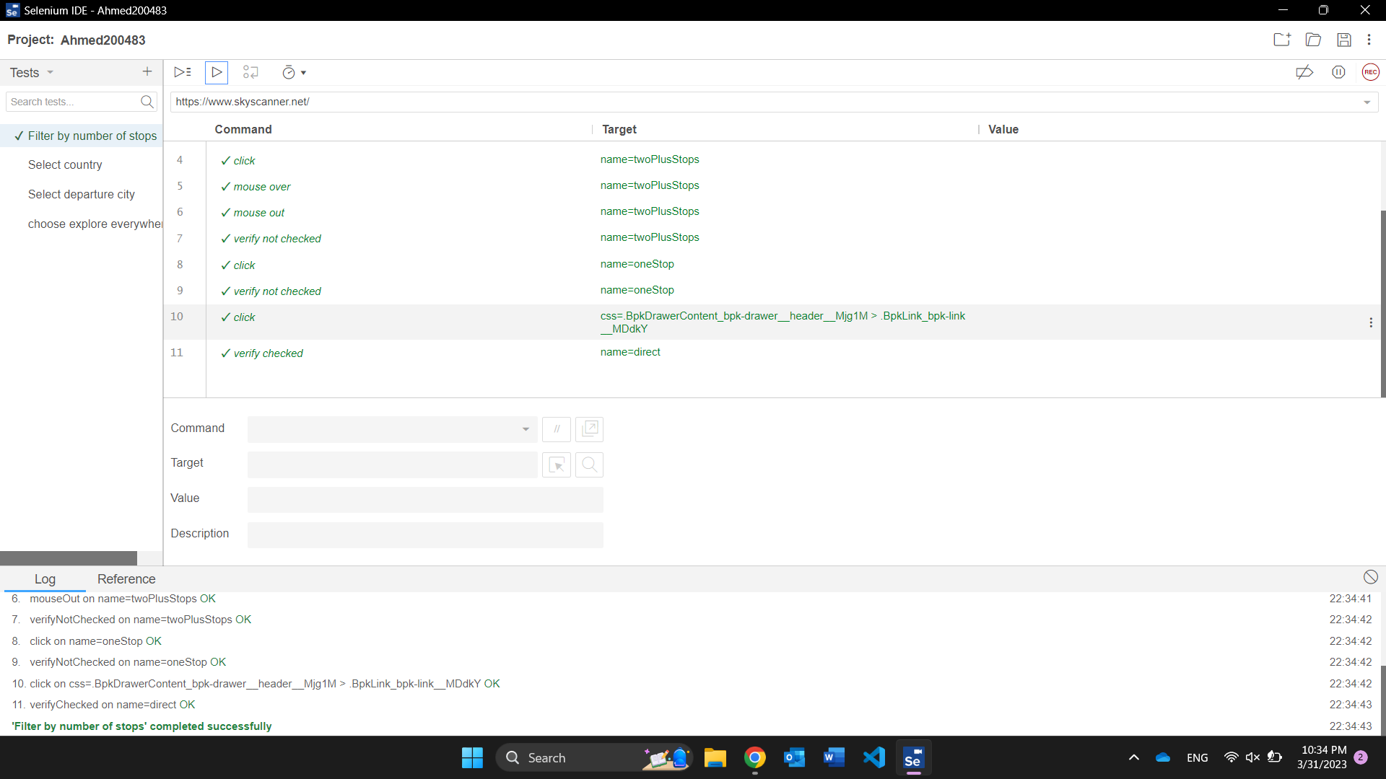

**Test suite:**

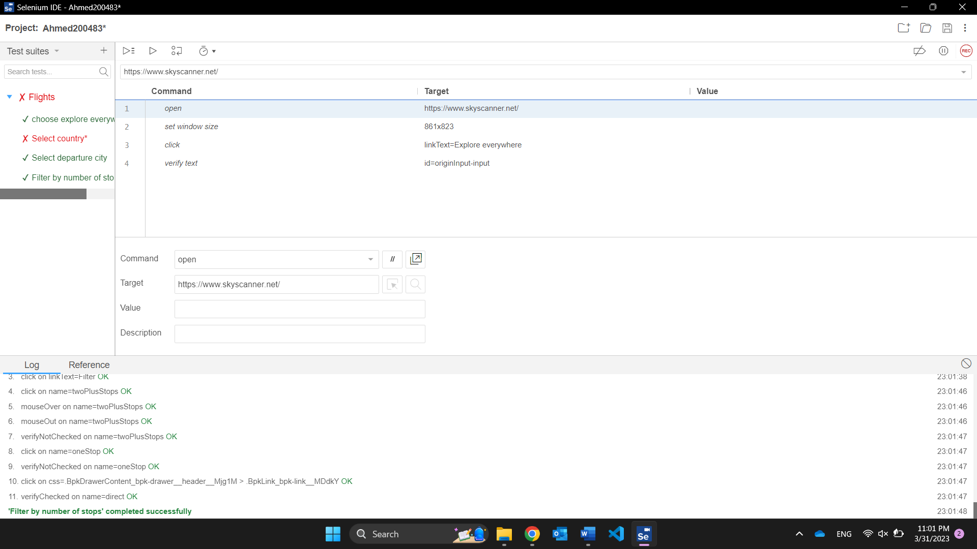

### Salma202235:

**Search car:**

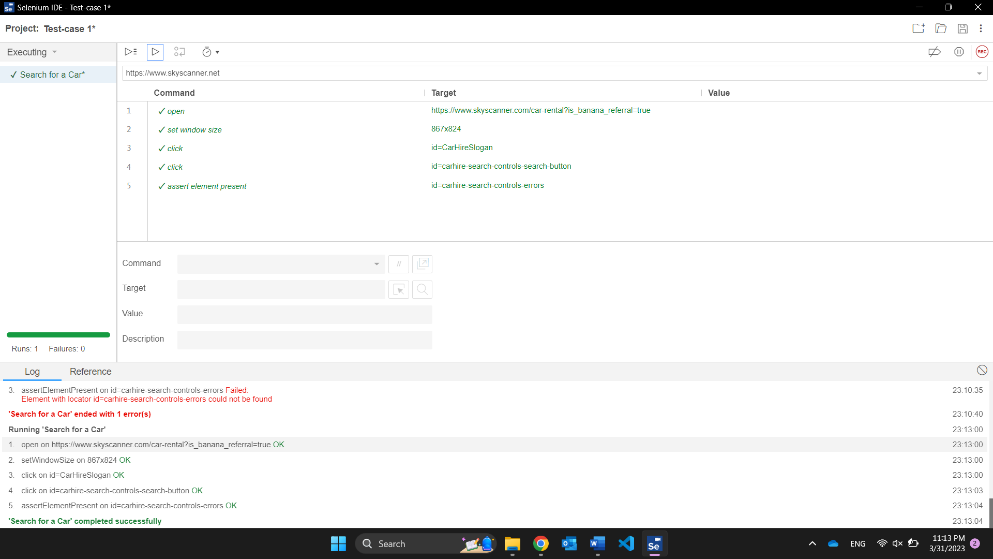

**Select car:**

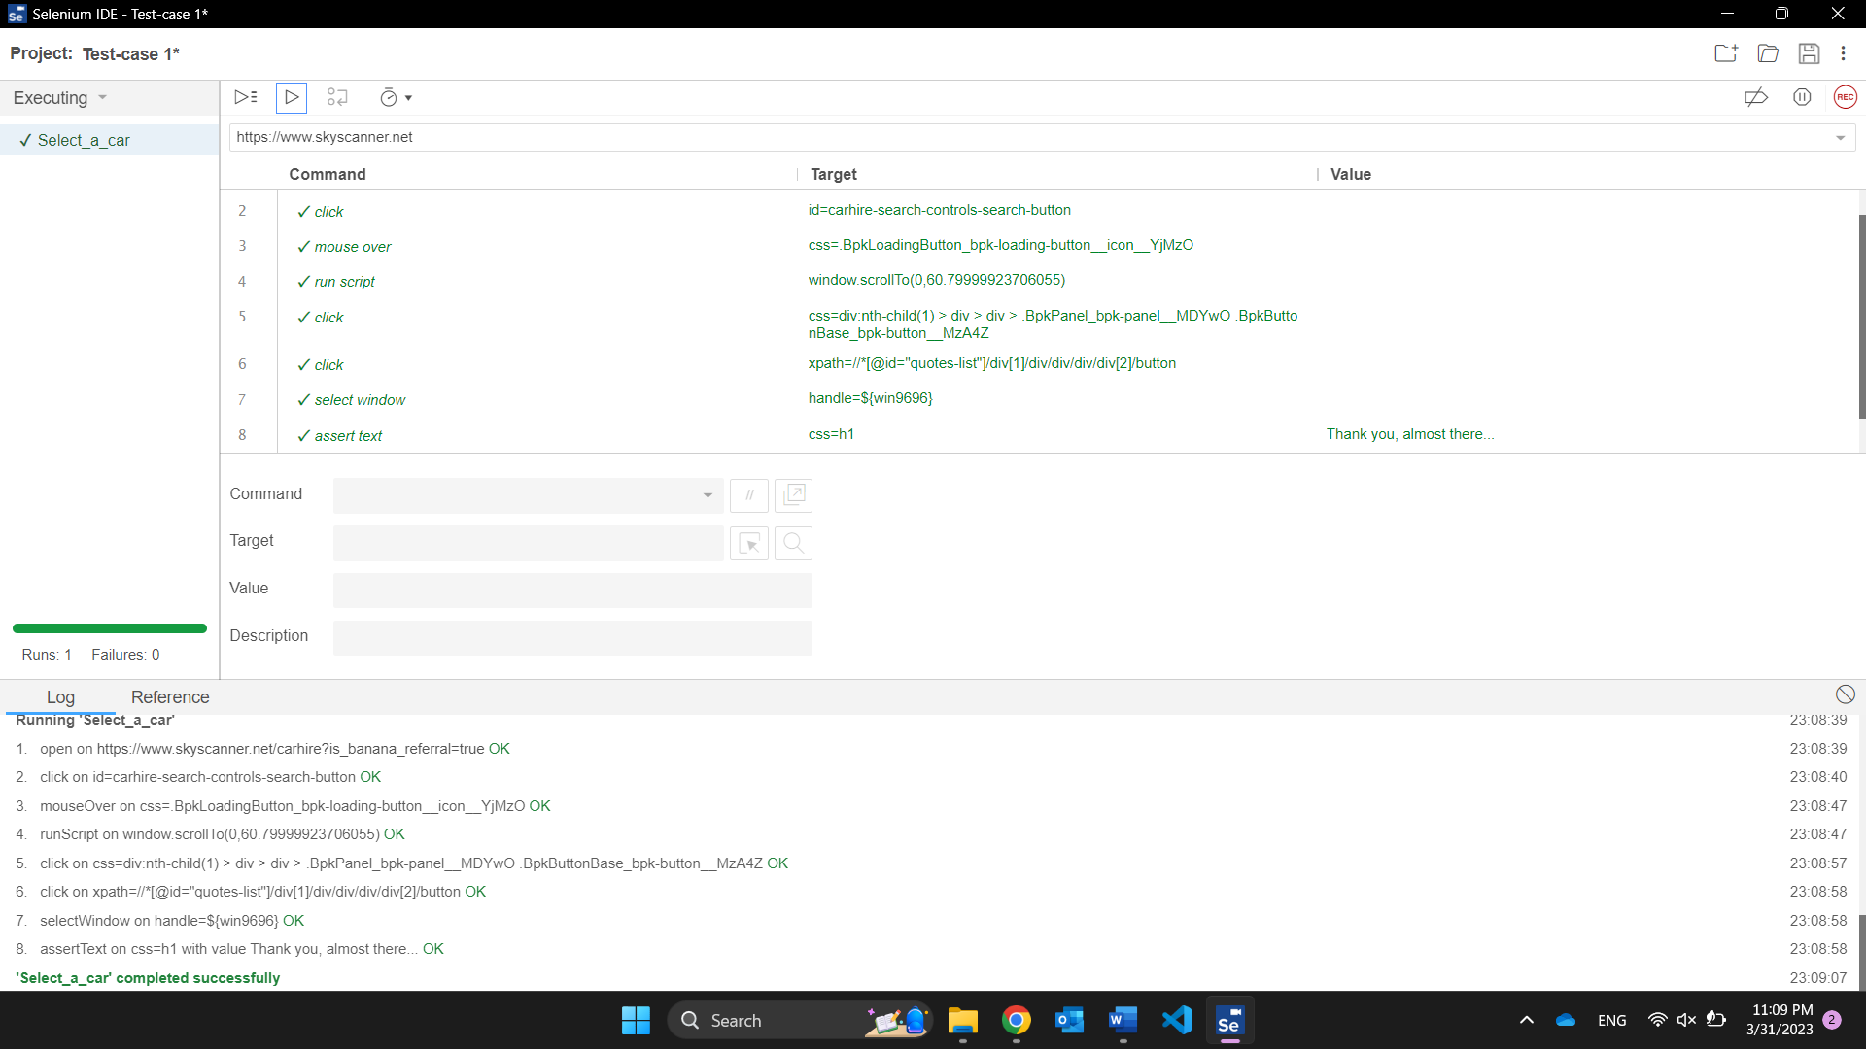

**View deals:**

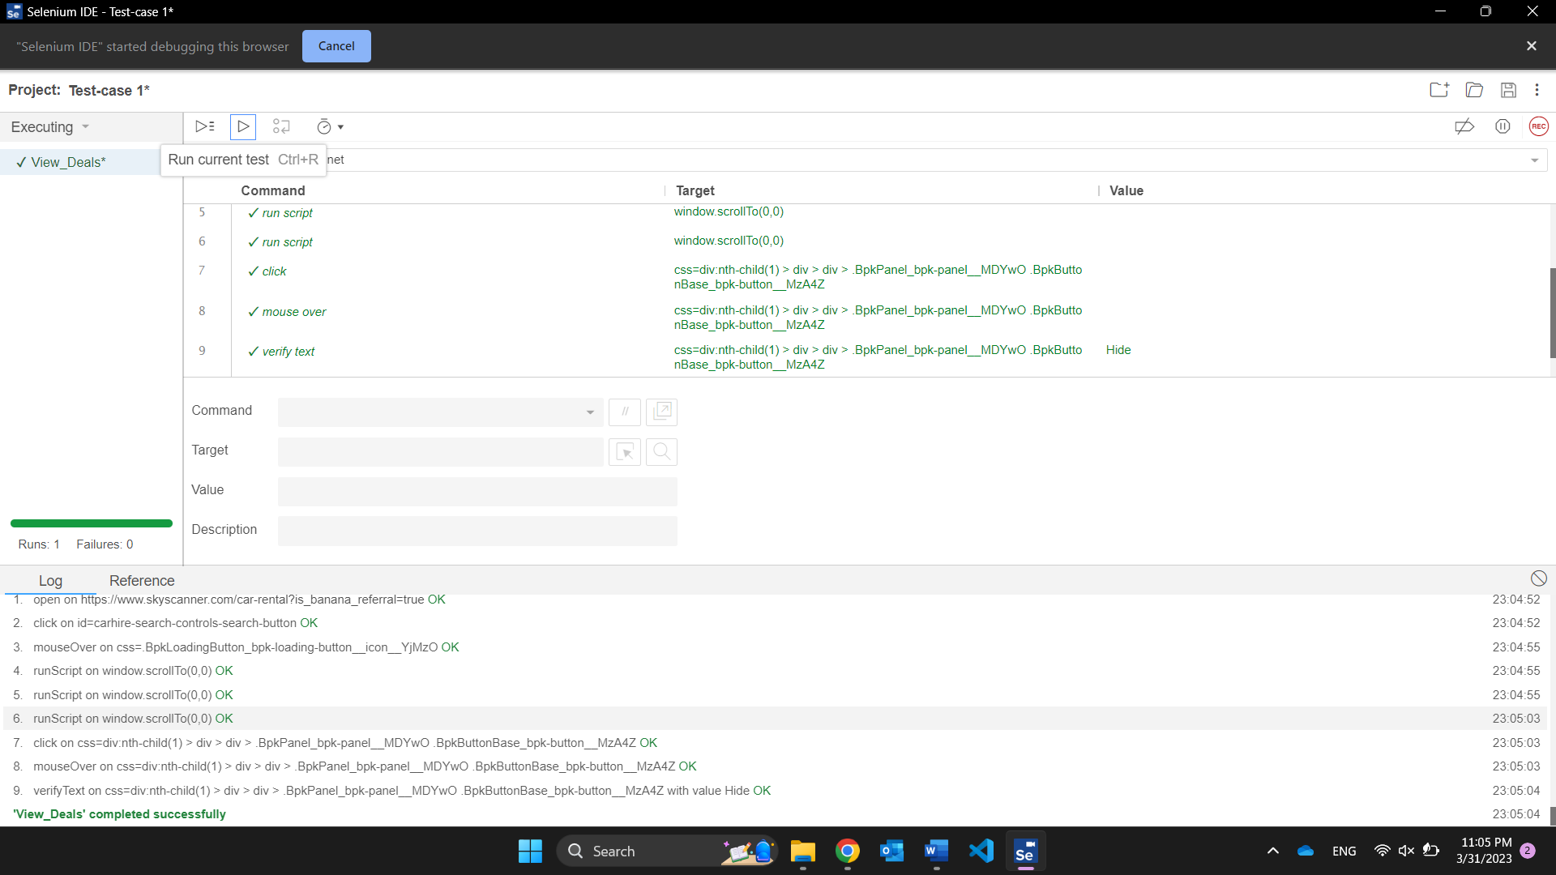

**Filter by car type:**

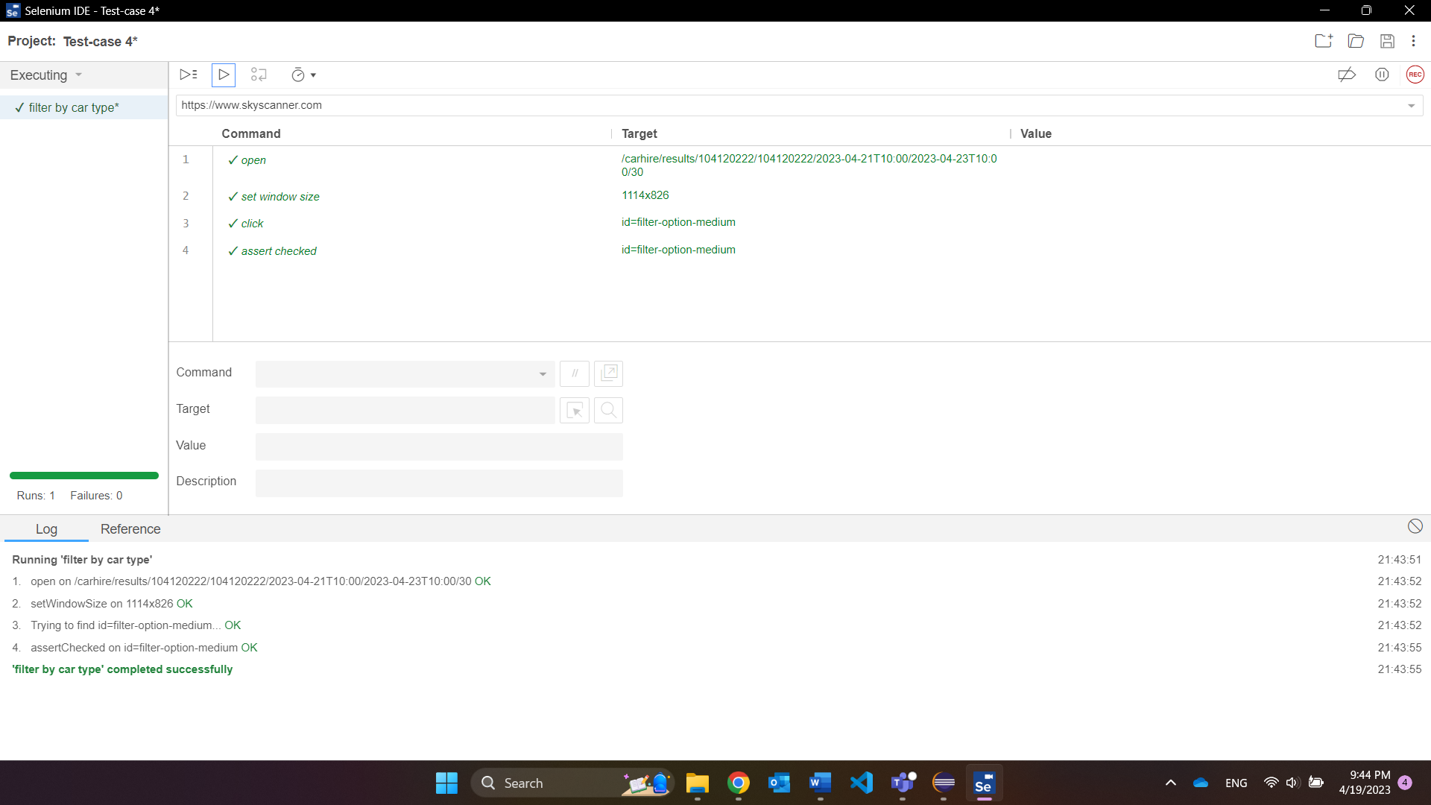

**Test suite:**

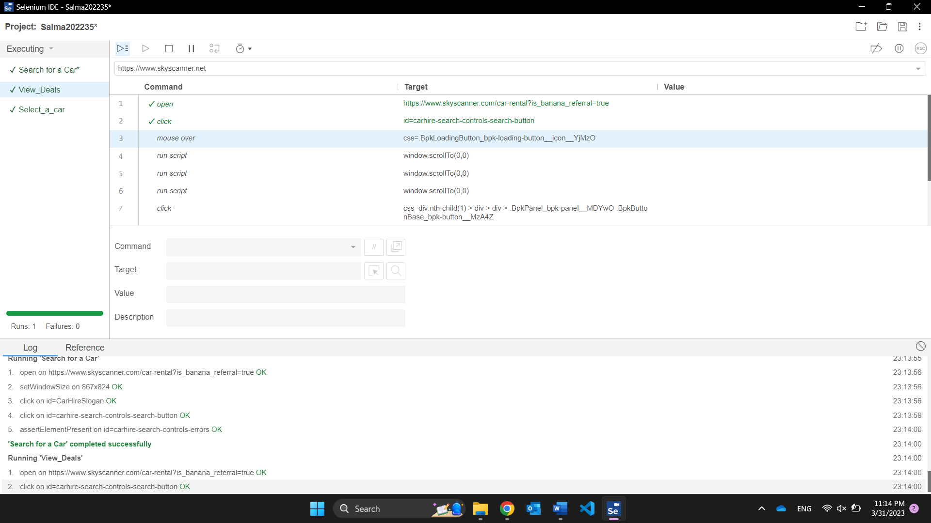

## Selenium WebDriver:

Captcha is appearing in all the test cases so no output is available to show.

## TestNG:

### Mayar192785: All must be run multiple times to give a passed test.

**Choose hotel category:**

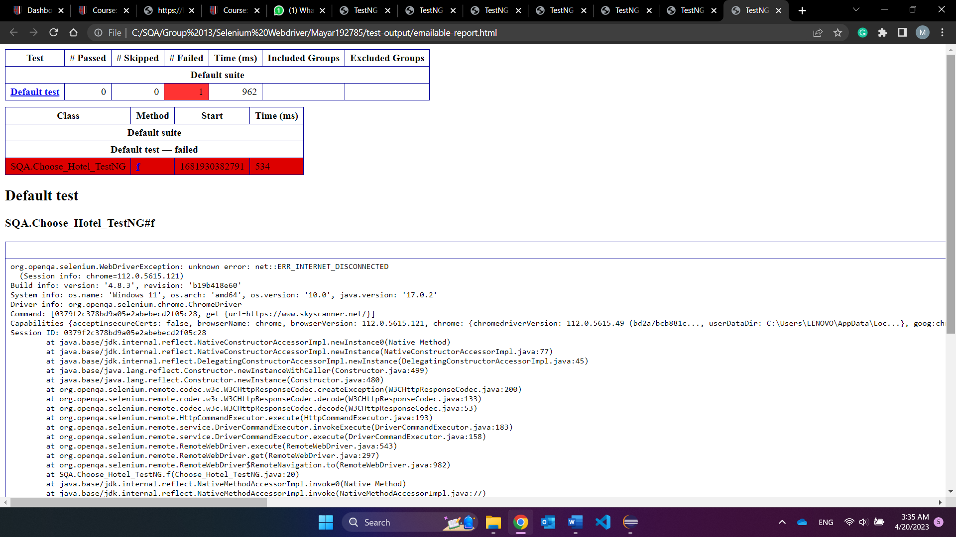

**Search for hotel:**

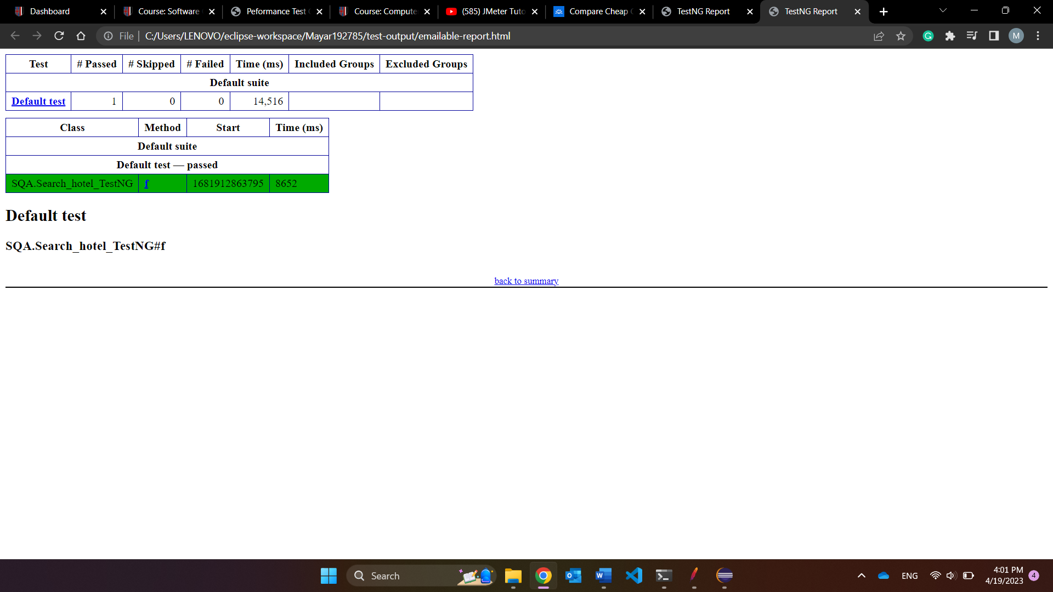

**Filter by budget:**

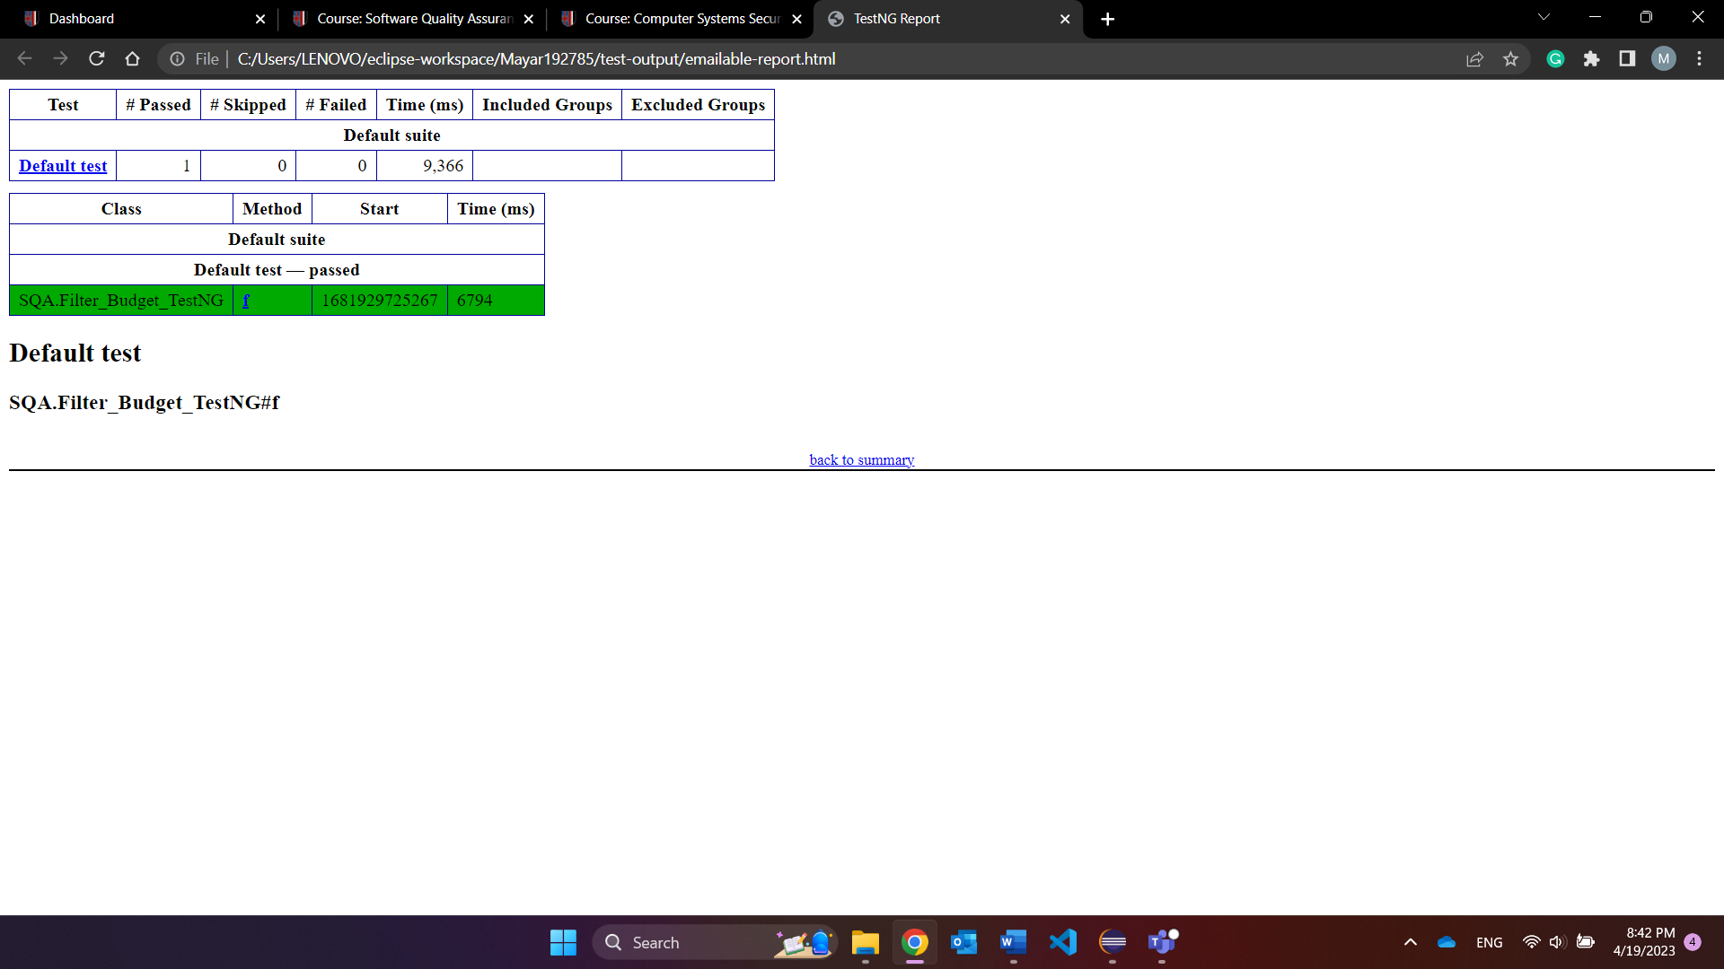

**View site:**

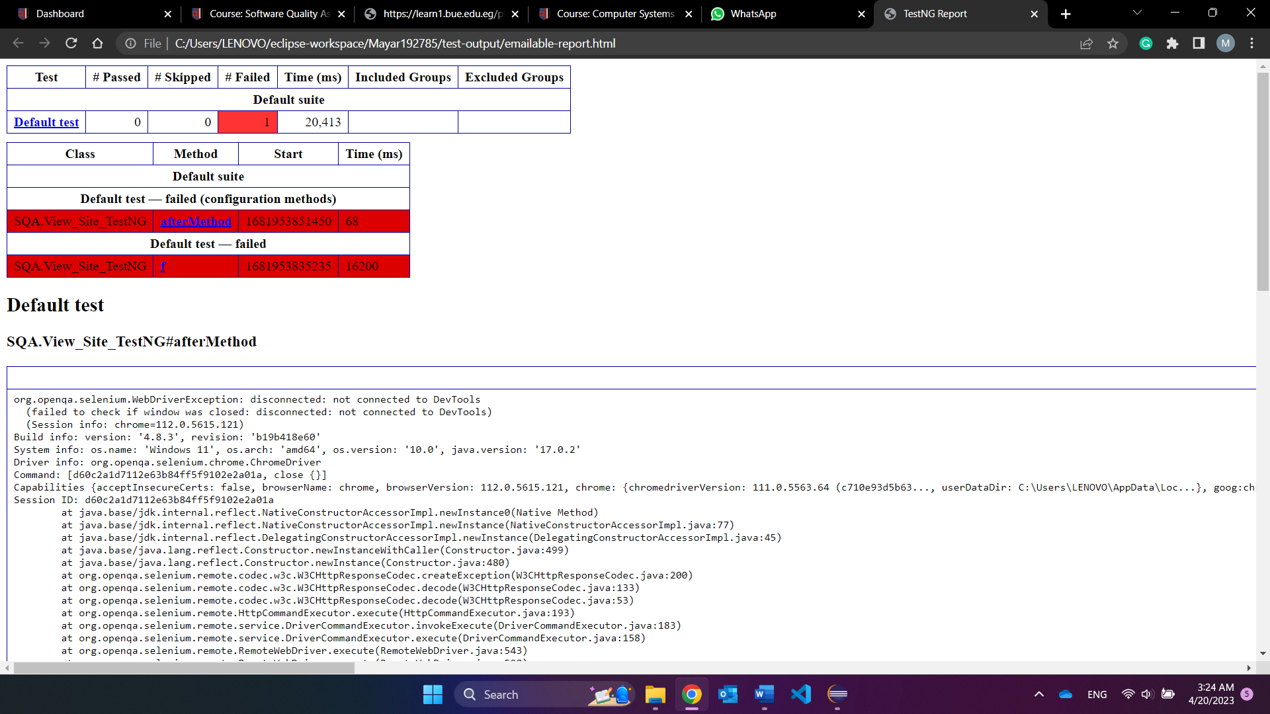

**View details:**

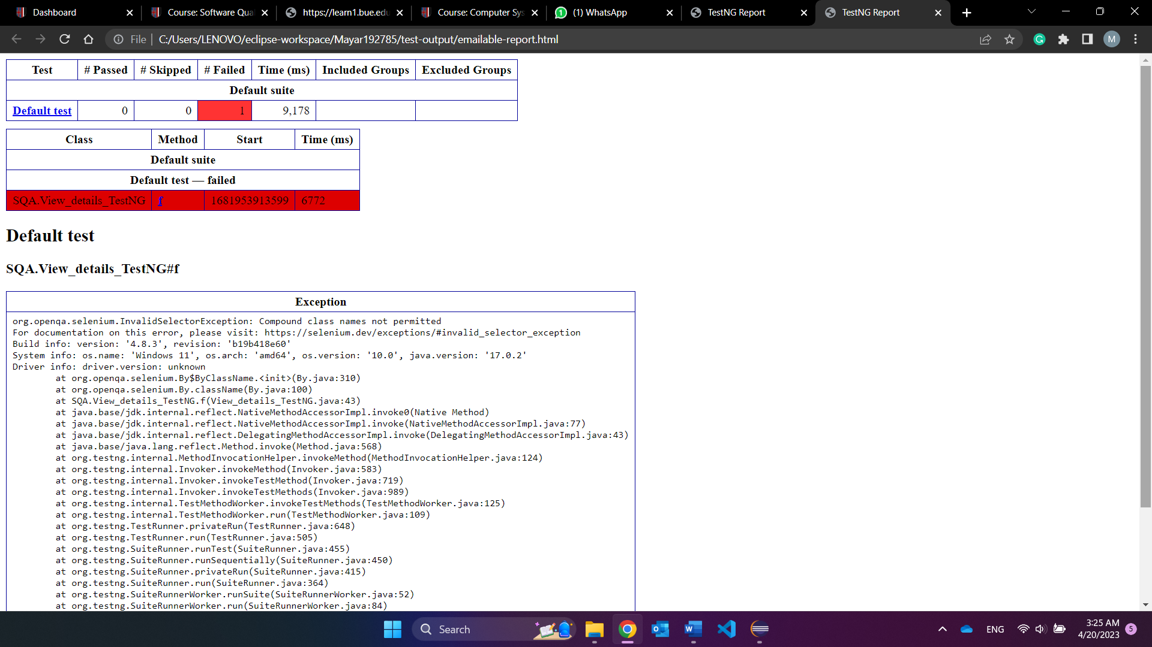

**Test Suite:**

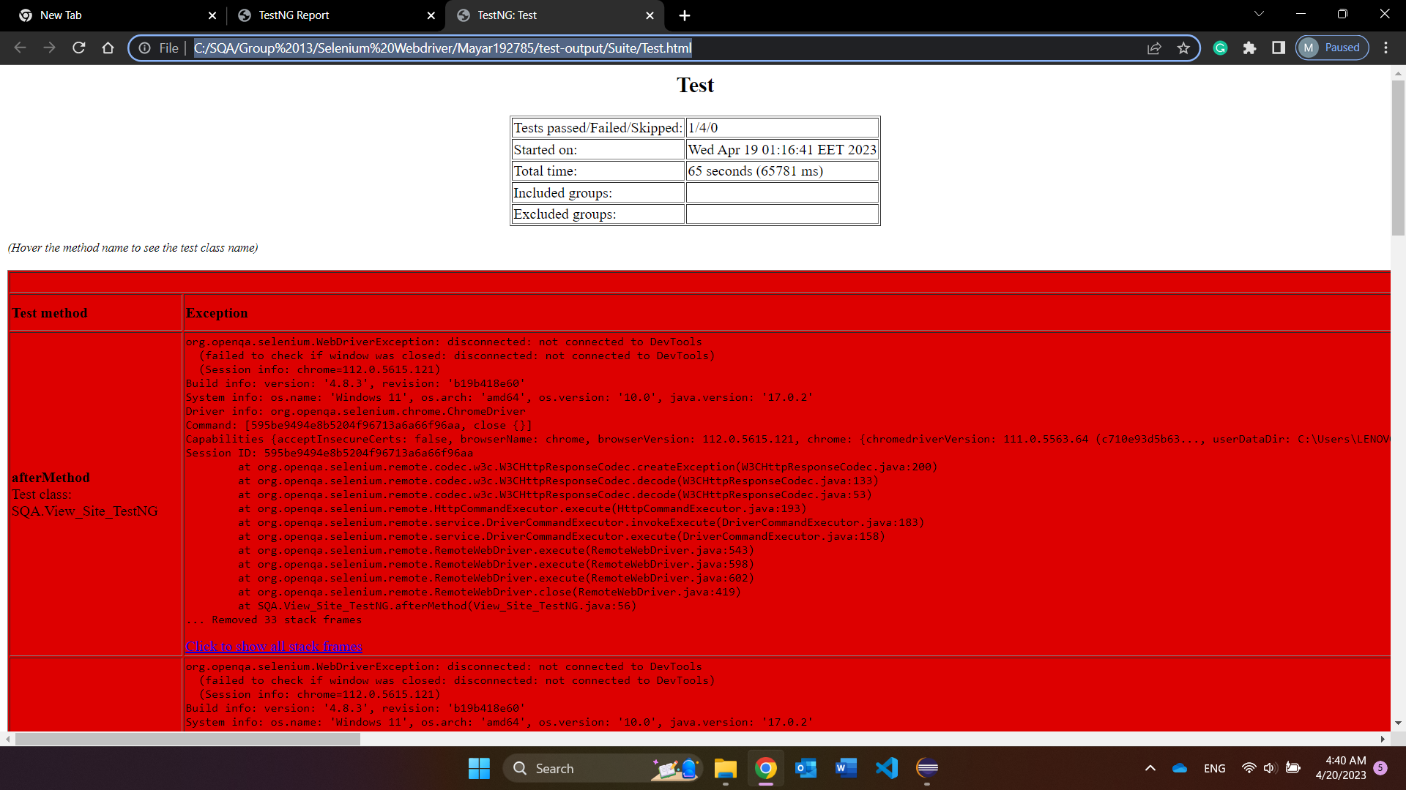

### Ahmed200483: All must be run multiple times to pass the test.

**Filter by number of stops:**

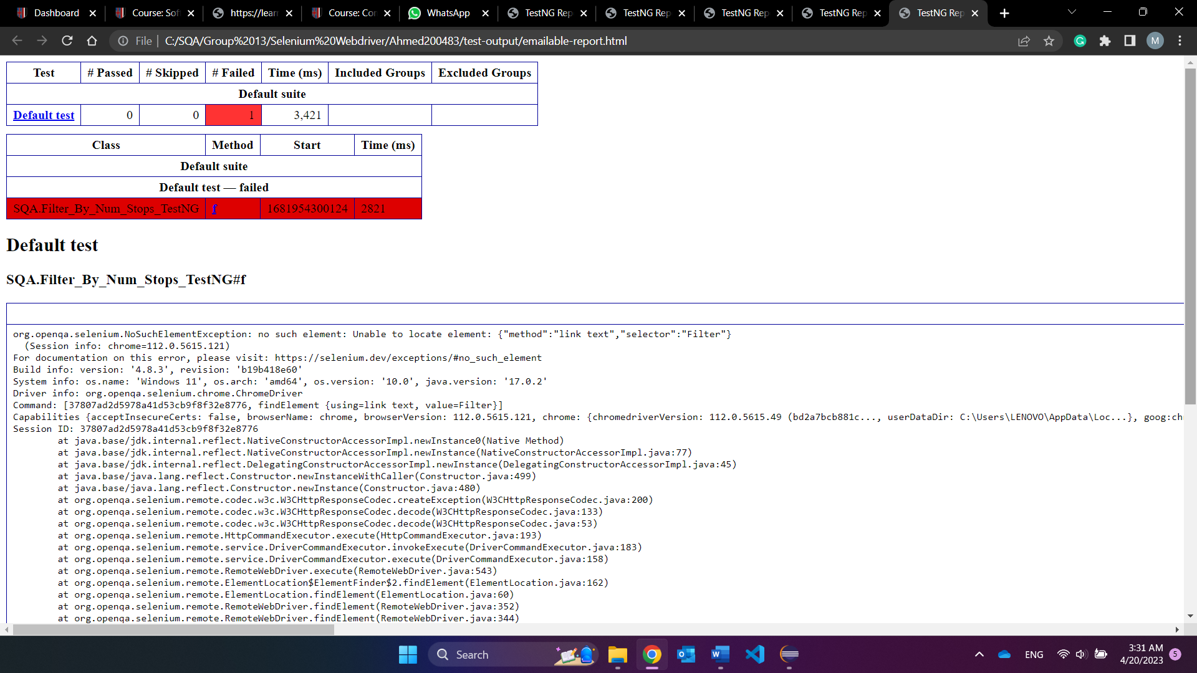

**Choose explore everywhere:**

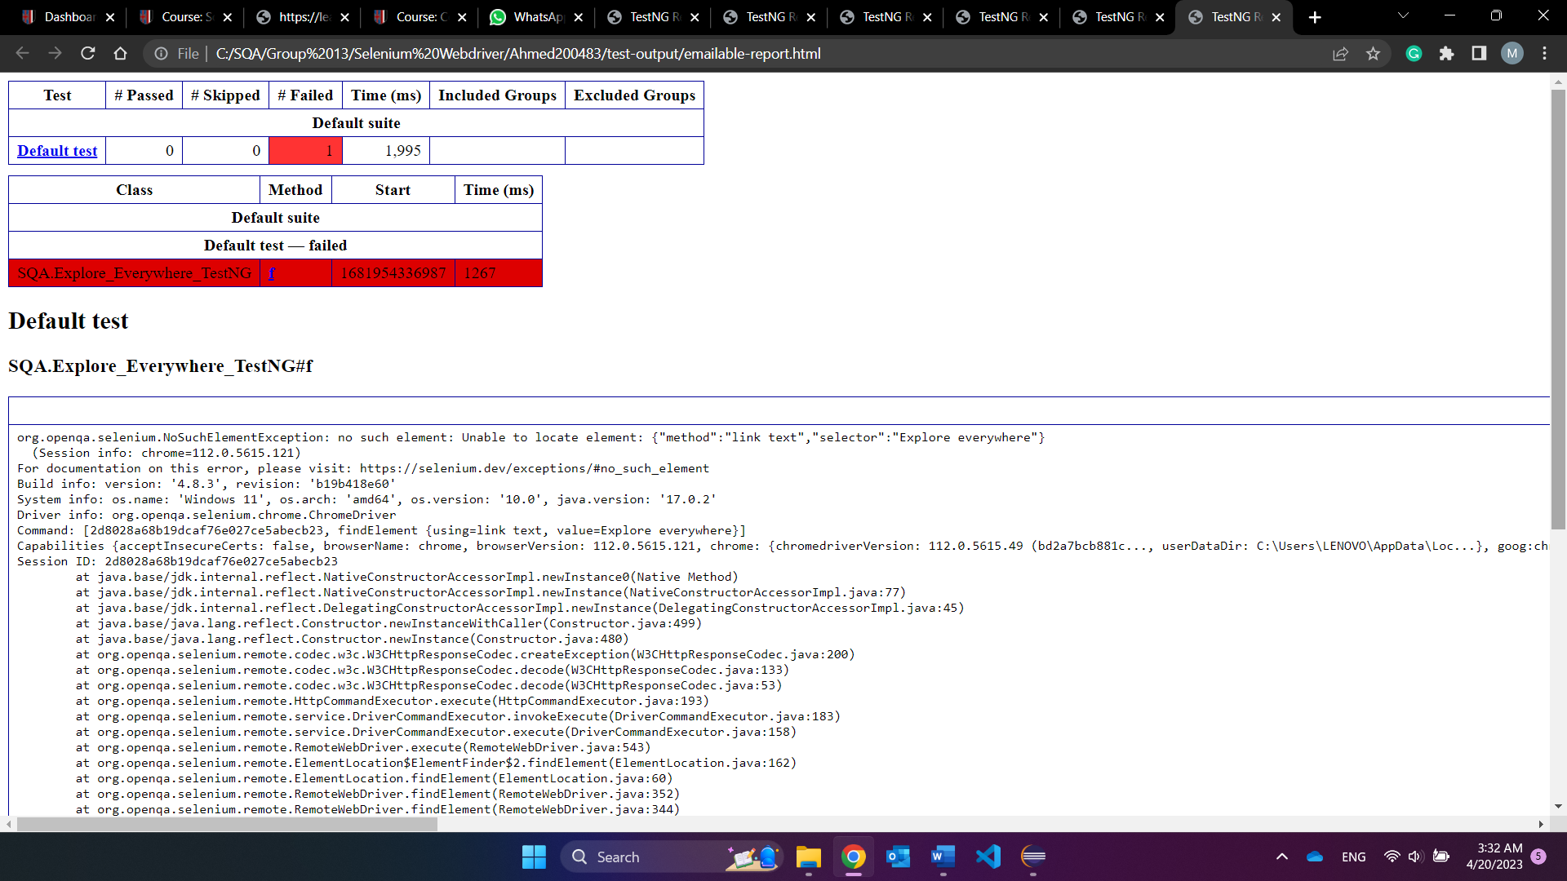

**Select destination country:**

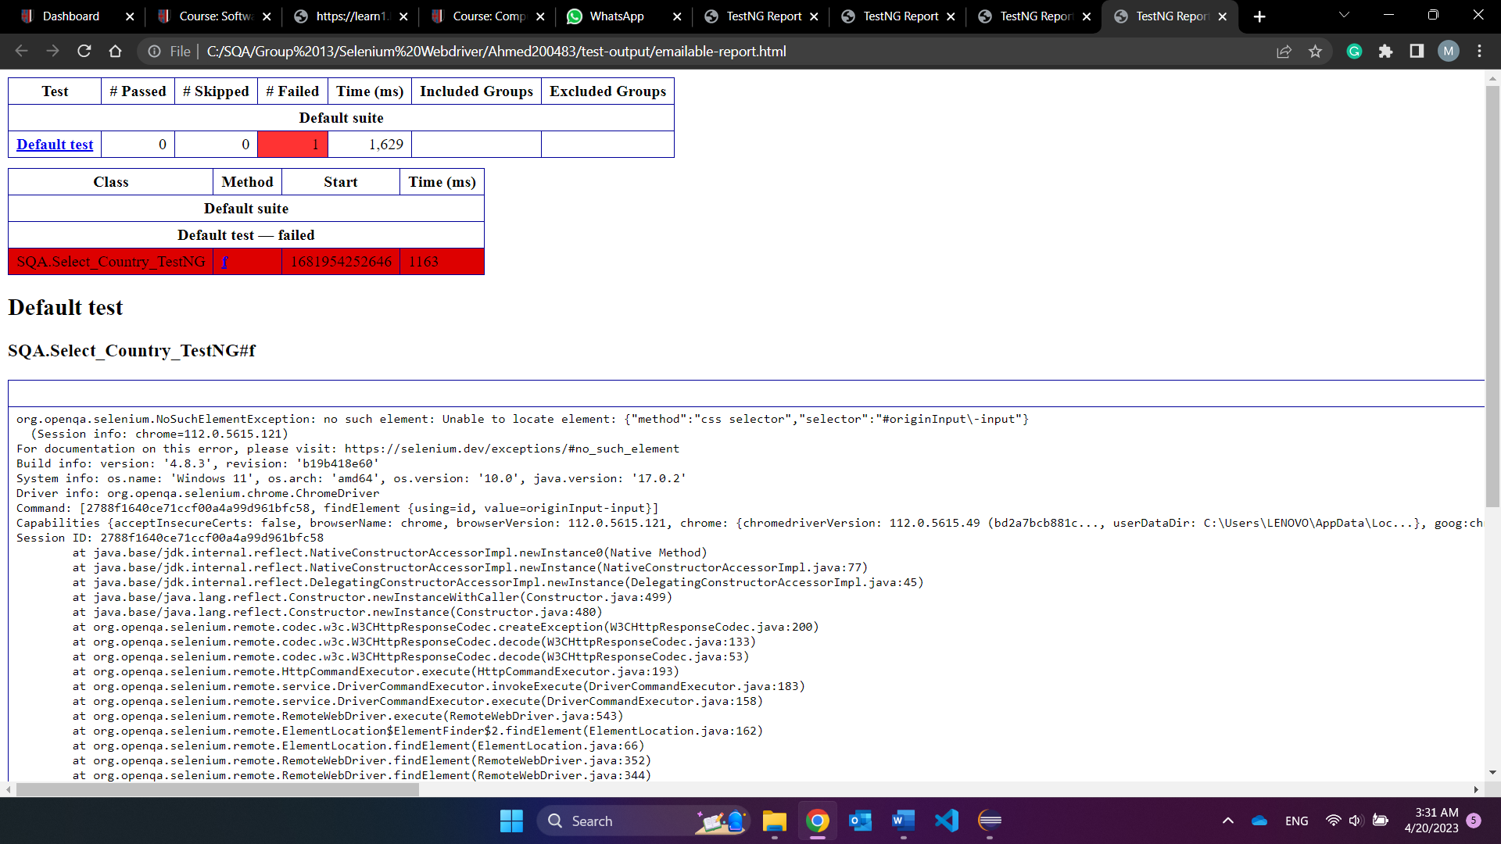

**Select flight deals:**

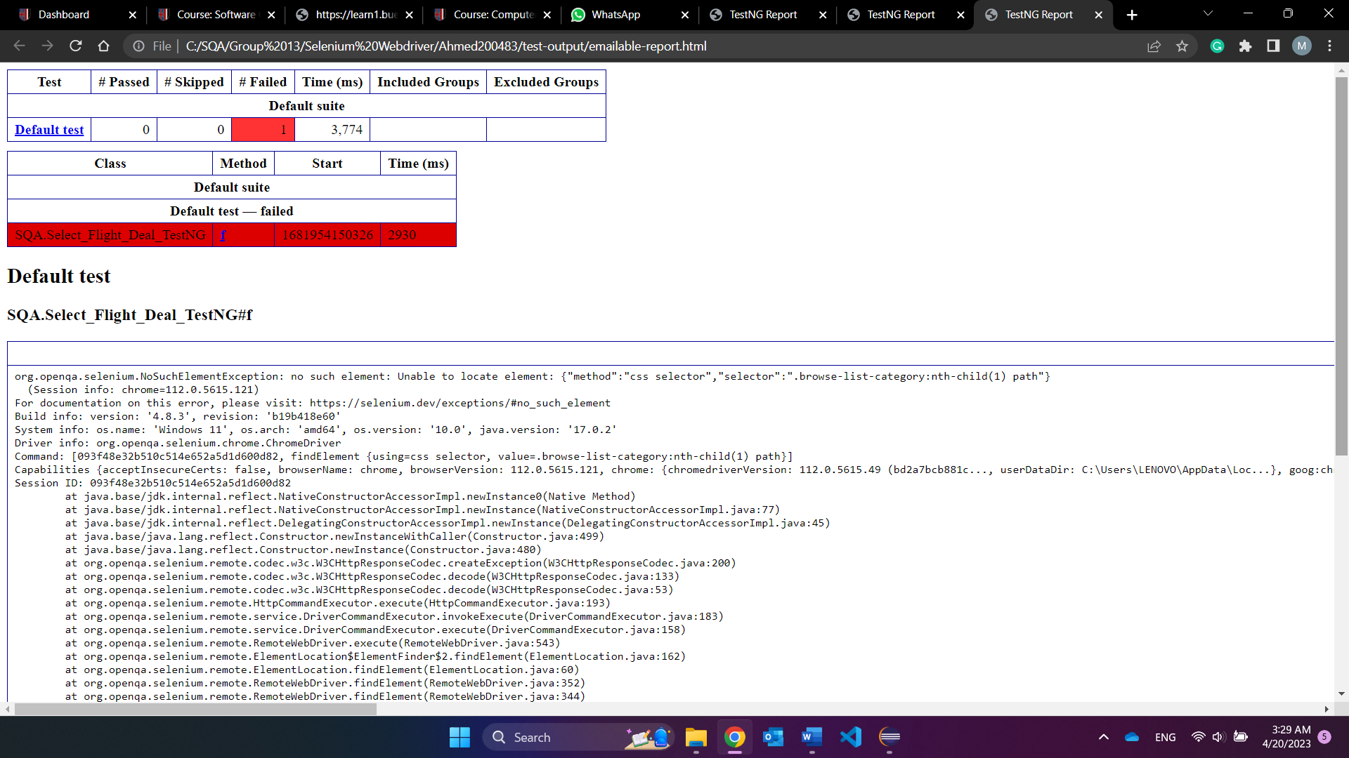

**Test suite:**

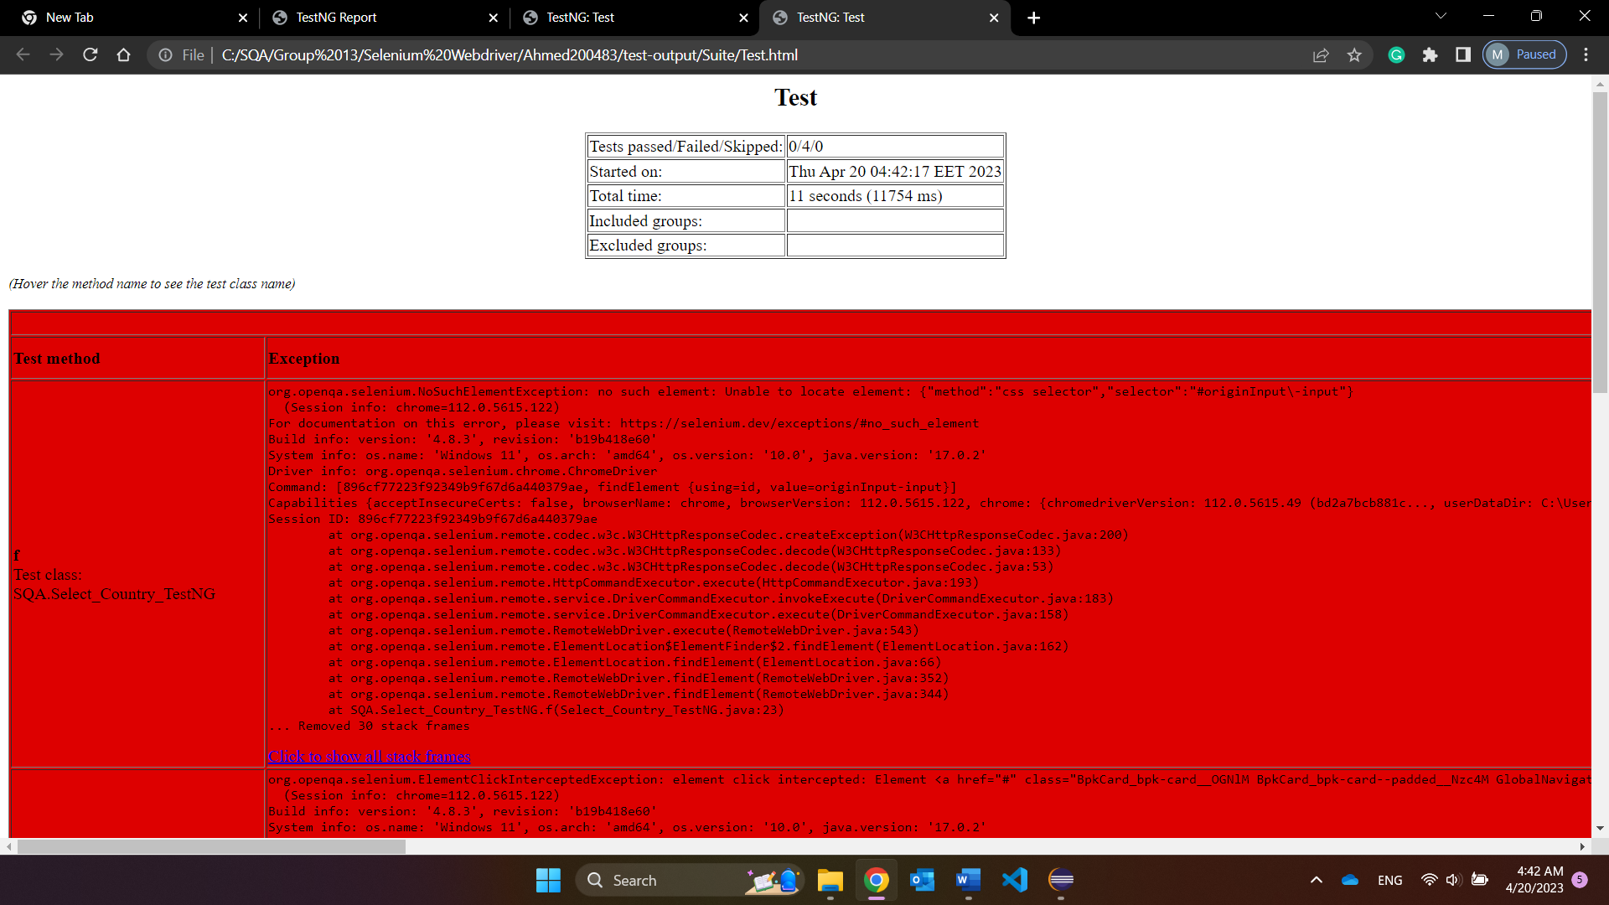

### Salma202235: All must be run multiple times to pass the test.

**View deals:**

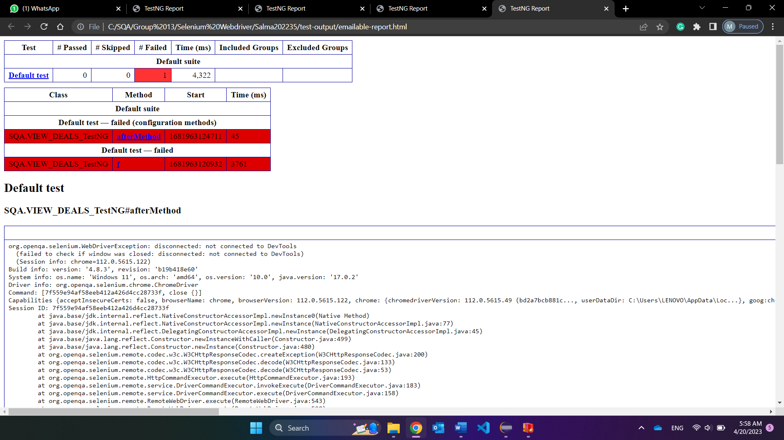

**Select car:**

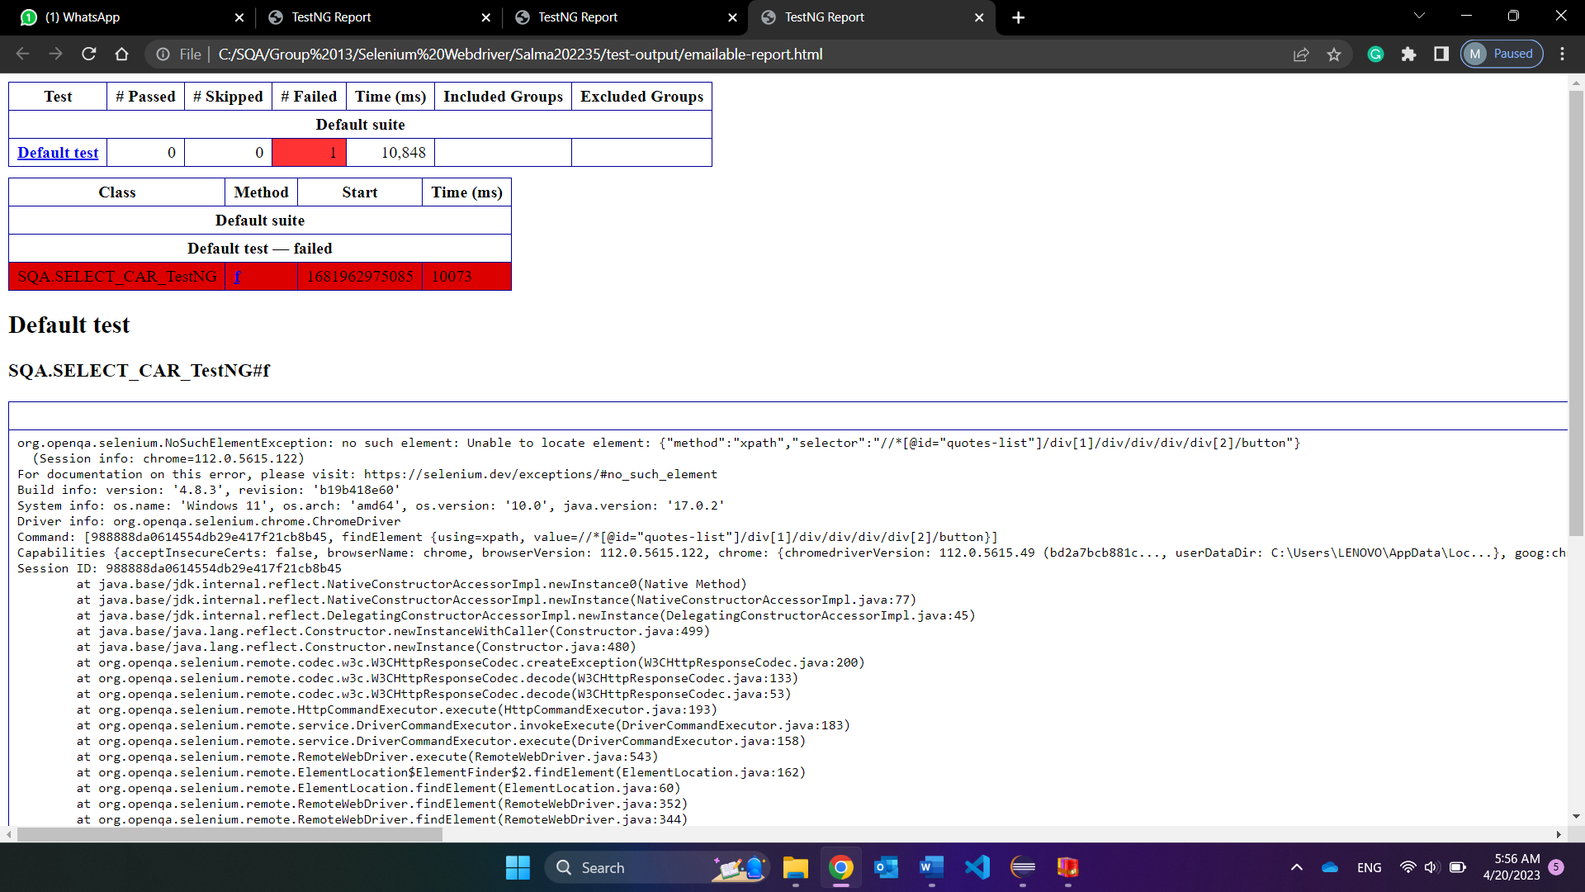

**Filter by car type:**

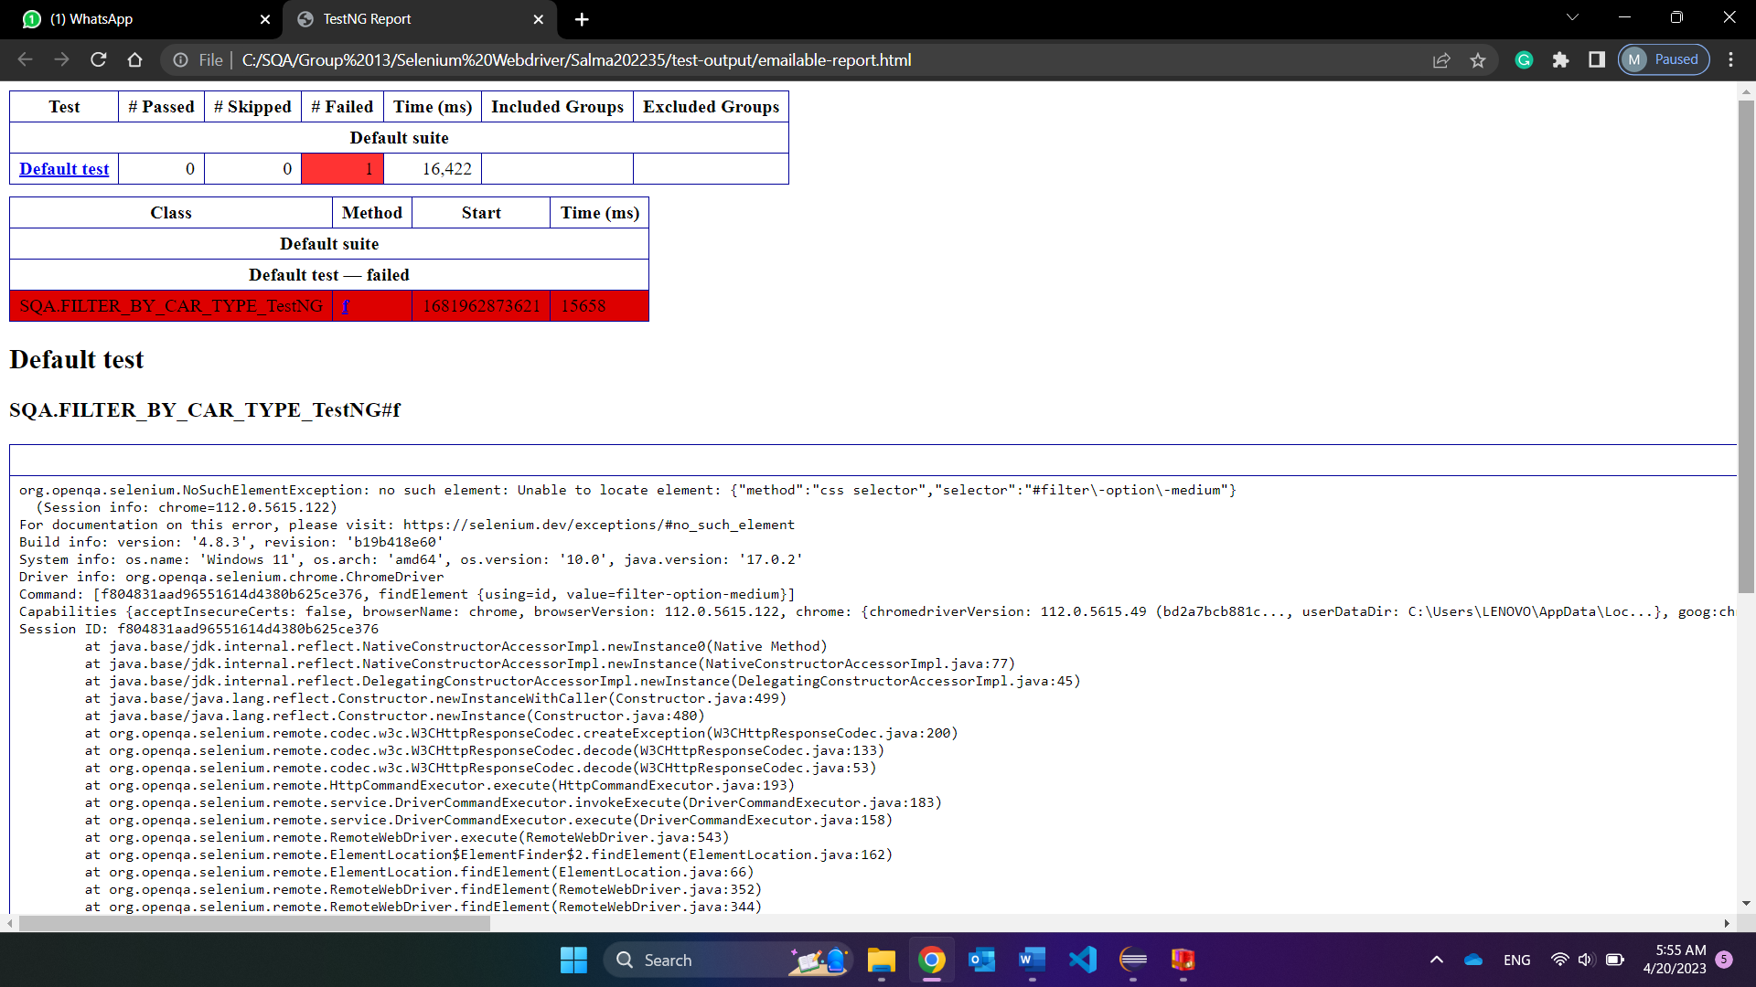

**Search by location:**

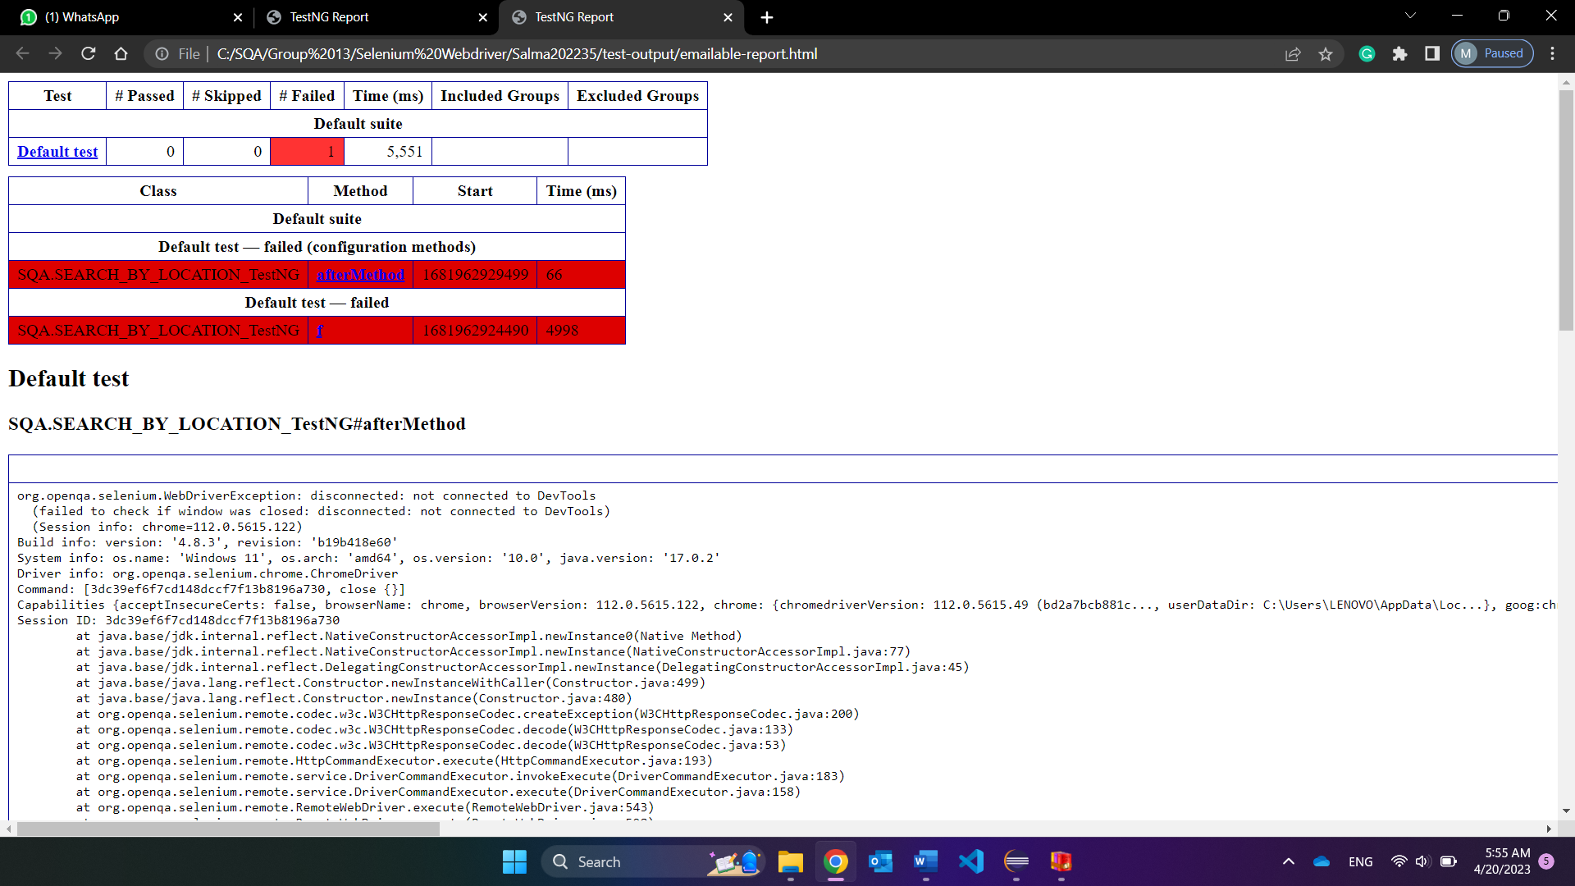

**Test Suite:**

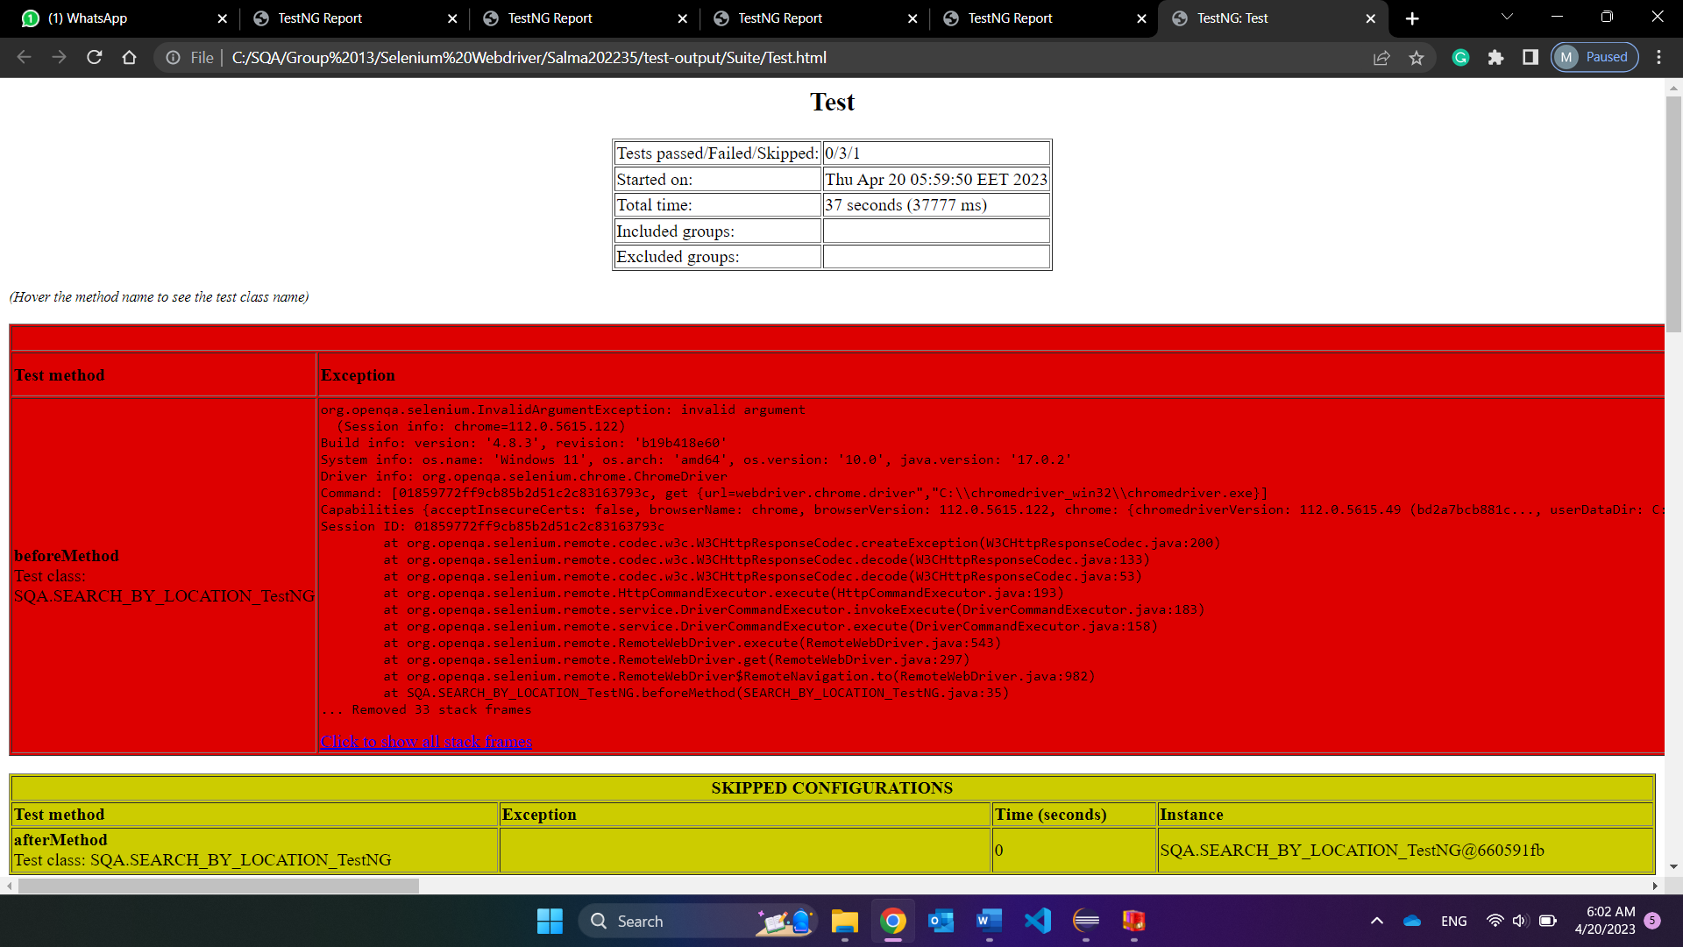

## Apache JMeter:

### View Results as Table:

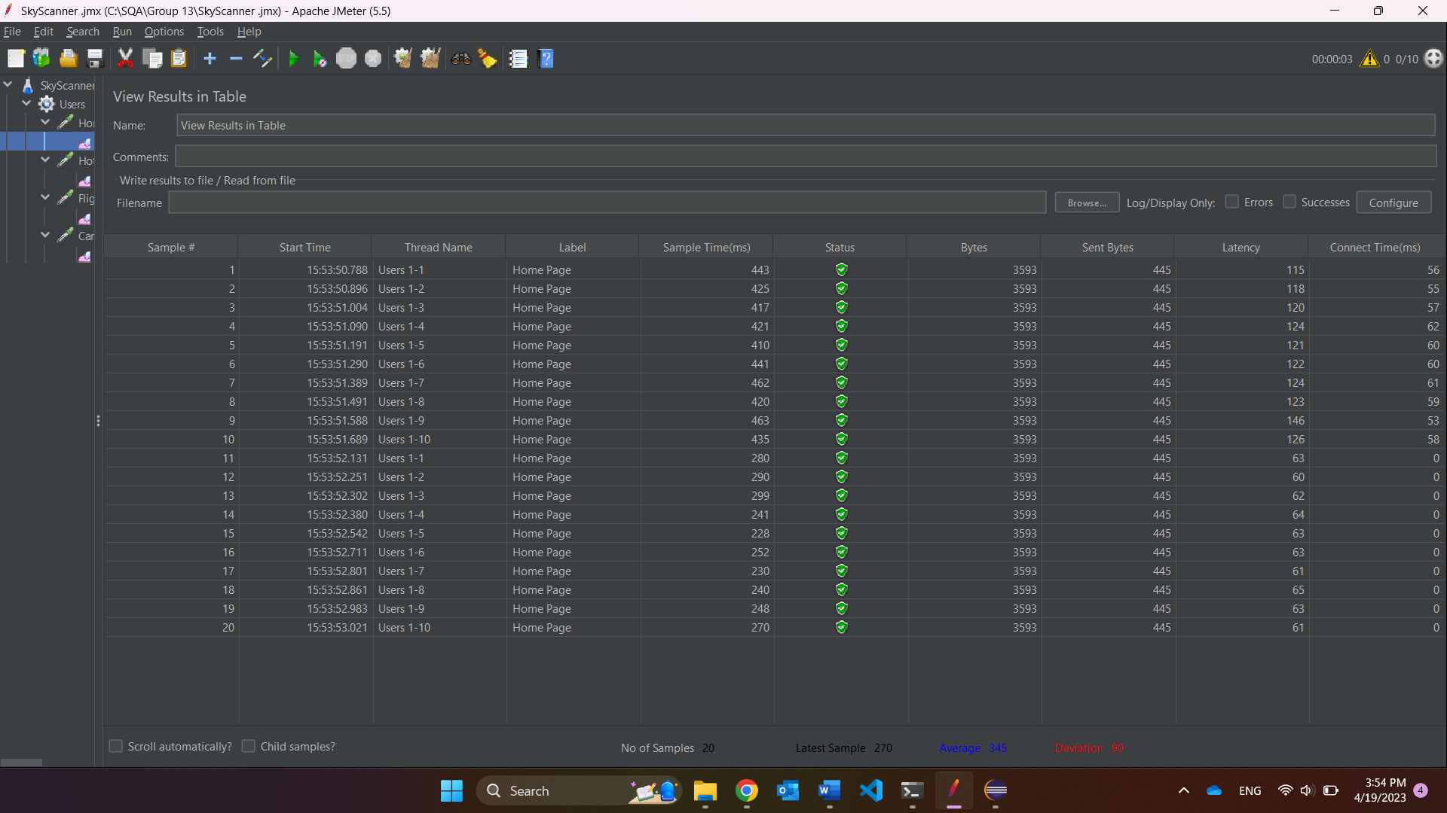

### View Results as Tree:

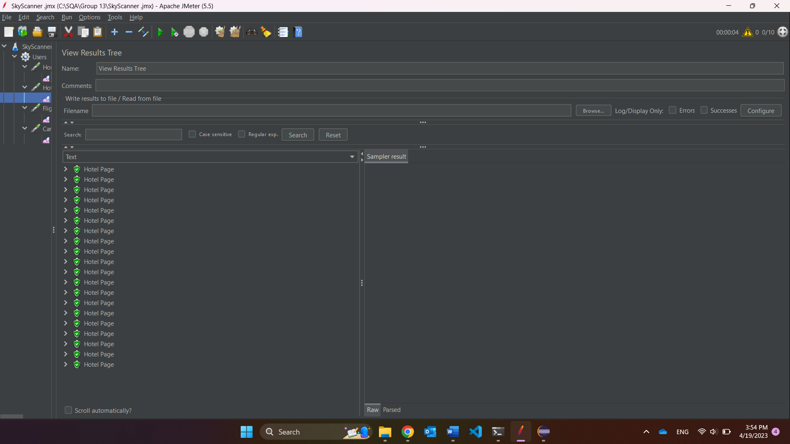

### Summary Report:

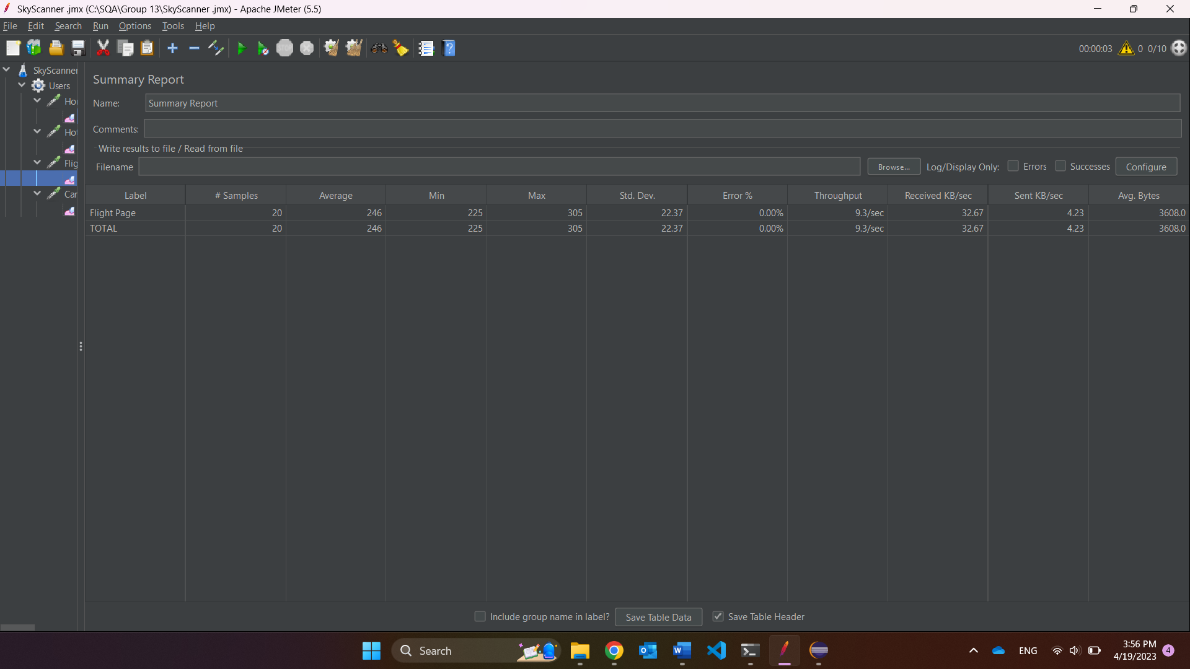

### Graph Results:

**10 users 2 loops:**

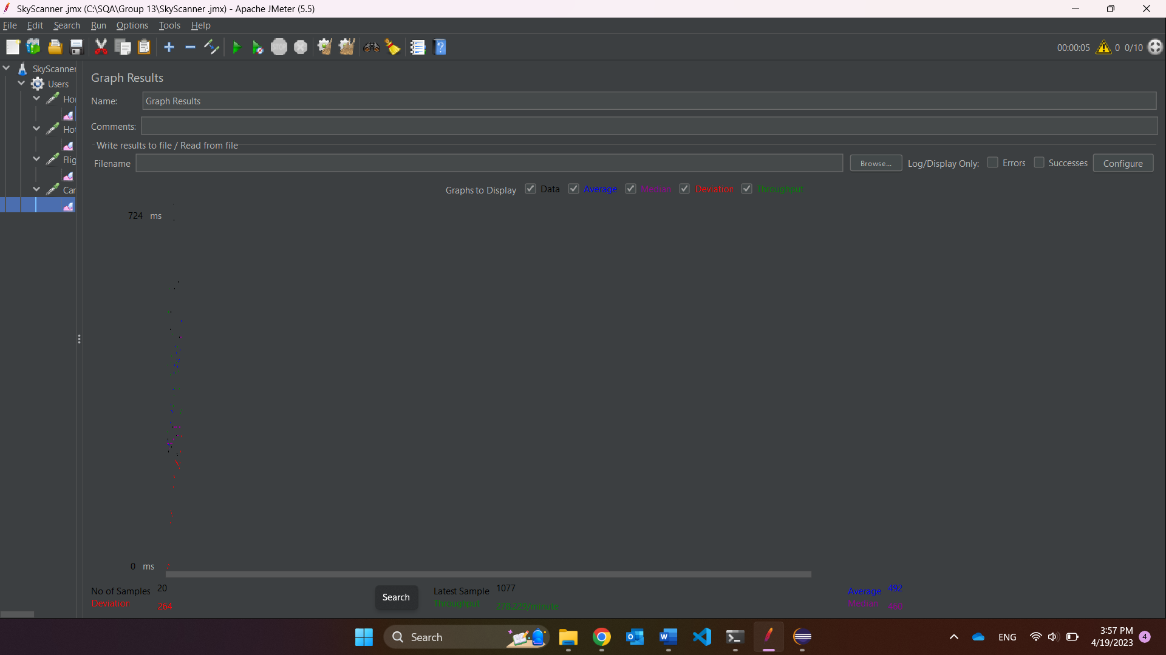

**100 users 5 loops:**

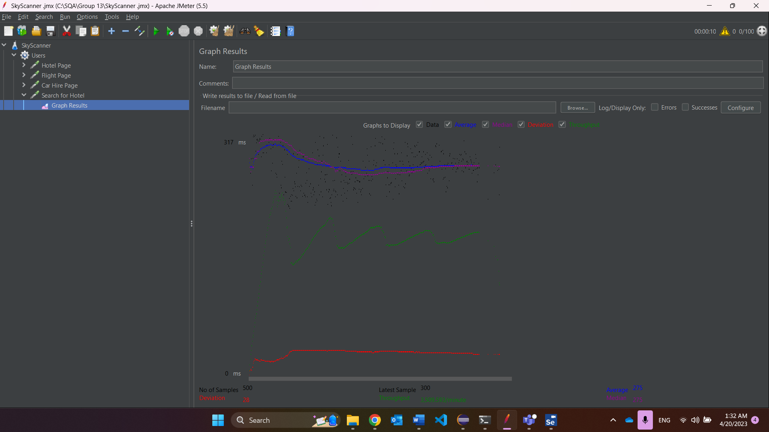

# Summary for each tool:

In conclusion, TestNG is easier tool to use where it performs testing

# Issues and Difficulties:

We ran into several issues that were frustrating and unsolved. While testing our test cases, we ran into incidents where the code was written correctly but the testing tool ran it as failed. After several trials, some were passed and some were still in the frozen phase and were decided to be failed. Another issue is that when running it several times, the website starts questioning our credentials and opens a captcha page, and there is no going back to the testing again; even if we try to solve the captcha manually, it does not confirm that we are not robots and stops on this page. We have tried to add some codes to solve that issue, but nothing has worked.